VI- Investigation of BIST Techniques

This section, which can be considered as the core of the project includes the phases 2 and 3 described in the Introduction, describing the investigated BIST strategies for both input pattern generation and output compression. We first discuss the terms of fault simulation, deterministic and alternative fault simulation techniques, different fault models, including single stuck at model QuickFault uses, Cell Fault Model (CFM)([23]), defended against single stuck at model in [3] and their comparison. Hierarchical vs. Board level faulting, opportunistic vs. cycle based simulation and pin/net faulting are described and the choices for the project fault simulations are justified([20]). Starting with board level faulting and then expanding to hierarchical faulting up to primitive cells, the multiplier design is simulated with respect to several input pattern generation techniques for efficient fault coverage. The techniques are described in an evolutionary manner in order to demonstrate how each new technique is initiated. The fault coverage result for each case is demonstrated and commented for pros and cons. All the plotted and listed data are also included in “CD>MSc/Results/designname”. The resultant data are either included in the text, or appended in the appendices or referred from the CD depending on the size of the data. Chronologically, this section starts after the completed design of CPAmultNxN, parameterized, signed, parallel, CPA multiplier up to the end of input test pattern generation techniques, after then, output compression technique and further simulations for larger multipliers are performed in a design → fault simulation manner for each top level design. As the signature analysis reveals extremely effective results, other techniques are not investigated and the output compression is concluded with signature analysis.

Before starting with the fault simulation of the phase, it is worth outlining the intermediate steps taken to convert the VHDL design into the simulated schematic format. The generated VHDL descriptions for the design in “CD>MSc/DesignFiles/Renoir/HDL” are first compiled into Autologic format using ‘qvhcom’ of QuickHDL and are shown in “CD:\MScCD\MSc\DesignFiles\Renoir\SynthCompiledData\component_name\”.
The compiled components are then synthesized and converted to eddm-schematic format using Autologic, and are shown in “CD:\MScCD\MSc\DesignFiles\Renoir\Eddm_sch\”. Then, the schematic files are opened in QuickFault and fault simulation is performed.
VI.1 – Fault Simulation and Fault Models

Fault simulation is the process of exercising the components of a given circuit under a predefined set of faults artificially inserted to the circuit, which depend on the postulated fault modeling. The objective of fault simulation is to verify the effectiveness of a devised test set as well as to improve a given test set for higher fault coverage. The most common types of faults in digital circuits are:
- stuck-at faults
- bridging faults
- stuck-open faults
- pattern sensitive faults

However, for computation cost issues, it is not rational to consider all these faults in fault simulation and usually more simplified fault models are used in most fault simulators. As described in [1] and [13], the commonly used technique is the single stuck at model, which is proven to also detect all multiple stuck at faults in a two level combinational circuit. Moreover, it is proven that a set of patterns, which detect all single stuck at faults will also detect bridging faults([1]). Although until recently this model was observed to be fairly adequate in fault representation in real circuits, particularly in bipolar technologies, the advanced CMOS technologies begin to produce faults, which cannot be modeled with the single stuck at model. A more comprehensive technique named “Cell Fault Model”, which is proposed in [23], is defended in [3] as a more realistic technique, but it lacks the required simulation tools for general acceptance. Nevertheless, [24] provides indirect techniques to utilize this model with the current single stuck at fault simulators.

There are several software techniques used for fault simulation, which can be listed as:
- commonly used techniques:
- Parallel fault simulation
- Deductive fault simulation
- Concurrent fault simulation
- more recent techniques
- Parallel Valued Lists (PVLs)
- Parallel pattern single fault propagation (PPSFP)
More detailed information about these can be obtained from [1] and [20], but is omitted in the context of this text. Another classification of fault simulation is based on the fault sampling technique used. A “deterministic” fault simulator, exactly wires to each net/pin stuck at 0 and stuck at 1 values and exhaustively exercises each node in the specified faulting hierarchy, a “statistical” fault simulator on the other hand uses probabilistic measures for the detectability of each node and uses the fault detection probabilities to compute the final estimated fault coverage. Obviously, the first technique favors precision while the second computation cost.

In all our fault simulations, we use Mentor Graphics’ QuickFault, which is a single stuck at, deterministic fault simulator.

VI.2 – Initiation Part-II:
Fault Simulation of 3x3 CPA Multiplier

After the design entry in Renoir and VHDL level simulation verification of the CPA multiplier, the leaf level design blocks and higher hierarchy blocks are synthesized into Eddm_schematic format. In order to describe the second phase of experimental route, firstly the 3x3 CPA multiplier is synthesized and simulated for faults. The generated schematic for the 3x3 multiplier is as shown in figure VI-1. The light rectangles connected to the pins of the components represent inserted stuck at 1 faults, while the dark ones represent inserted stuck at 0 faults.
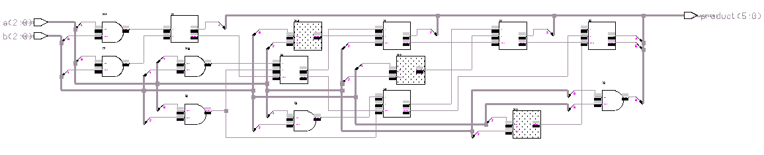
Figure VI-1, Generated CPAmult3x3schematic with inserted faults

As seen in the figure, the faults are inserted at board level, therefore, the internal pins and nets of these blocks are assumed to be non-faulty. This approach is prone to the criticism that the blocks like FA and MSBFA are quite complex, and assuming their internal nodes are fault free is an overoptimistic assumption. However, for hierarchical level simulation, the internal primitives, which are supplied by the vendor must be known and these vary from application to application diminishing the possibility of a generally acceptable model. Another approach, named Cell Fault Model, which is introduced by [23] suggests a different strategy, which is defended to be more comprehensive in [3]. With this board level simulation, there are 112 faults injected in the 3x3 multiplier. The fault list for the inserted faults are appended in Appendix D-1, to provide an example to the fault list format QuickFault produces. The pins are described as: instance/pin, and as seen in the appendix, there is one stuck at 0 and one stuck at 1 fault per pin. DT represents the status of the fault being detected. All the QuickFault fault classifications are defined in [20, pp. 1-14 – 1-15].

In order to determine the fault coverage for the 3x3 multiplier, we devised a simple exhaustive test pattern generation scheme, an upcounter which generates all the possible 2⁶ = 64 inputs to the 3x3 multiplier. The 6 bit upcounter as the input pattern generator provides the patterns as:
Bits | decimal
000000 | 0
000001 | 1
. | .
. | .
. | .
111111 | 2⁶-1=63

The forcefile, which produces the stimulus is listed in Appendix D-2, to provide an example to the forcefile format used in QuickFault – the general simulation environment being QuickSim. Hence, all other fault lists and stimulus files are referred from the CD and are not appended in the report due to unmanageable hardcopy volumes. For the fault simulation, cycle based testing is used which represents an Automatic Test Equipment (ATE), much realistically, than the opportunistic test. The stimulus provides a new test pattern every 50ns and therefore, the primary output, product, is strobed every 40 ns after each new pattern is provided and as the QuickFault allows only compare window testing rather than single sampling point ([25, pp. 10 - 12]) the strobing window is chosen as 5 ns. With 40 ns after the test vector application, all the outputs are well stabilized and therefore unrealistic high fault detection results due to the comparison of transient values are prevented. The defined test cycle information is as shown below:

NAME: cyc1 Period: 50.0

DETECTORS:
After Window
------ ------
40.0 5.0

EVENT STREAM:
Event Supersede Time
----- --------- ----
EN no 0.0ns

With the above described setup for primary output tests and input stimuli, we have run the fault simulation, and the total of 64 patterns which test the circuit for all possible input combinations are expected to have a 100% fault coverage, as long as there is no inherent redundancy in the circuit. As QuickFault also extracts information for schematic level simulation, the schematic level simulation results are also observed from QuickFault during fault simulation. The simulation result for an exemplary period of simulation is plotted in figure VI-2.

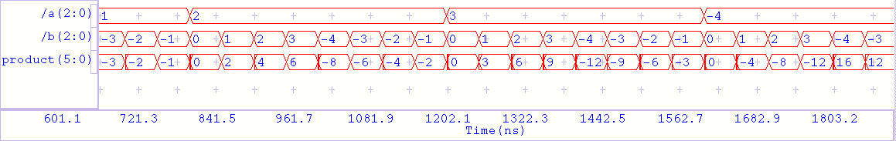
Figure VI-2, Schematic Level Simulation Trace for 3x3 Multiplier

As can also be observed in the fault list, all the faults are detected in 37 cycles out of 64. which reveals, when starting from 000000, around 40% of the exhaustive test is redundant in multiplier testing. As shown in figure VI-3, 100100 is the last effective test pattern in the input test set.
bits | decimal
000000 | 0
000001  Required  Redundant | 1
. | .
. | .
100100 | 36
. | .
. | .
111111 | 2⁶-1=63

Figure VI-3,Effectiveness of applied input patterns

The overall grade of fault simulation for the 3x3 multiplier, as shown below, shows, as expected, 100% fault coverage is achieved with the exhaustive test.

CURRENT STATUS
--------------
Total Faults : 112
Unsimulated Faults : 0

RESULTS FROM LAST RUN
---------------------
Run Time : 3300.0ns
Total Faults : 112
Untestable Faults : 0
Testable Faults : 112
Undetected Faults : 0 (0.00%)
Detected Faults : 112 (100.00%)
Possible Faults : 0 (0.00%)
Hyperactive Faults : 0 (0.00%)
Hypertrophic Faults : 0 (0.00%)
Oscillatory Faults : 0 (0.00%)
HM Dropped Faults : 0 (0.00%)

Hence, fault grade information is useful to observe the overall effect of applied test patterns, but does not reveal any information about how the percentage of detection builds up. In order to see the accumulation of fault detection QuickFault provides a plot of fault coverage percentage vs. input test cycles and a histogram of number of detected faults at each cycle. As seen in the fault coverage plot for the 3x3 multiplier in figure VI-4, the fault coverage ascends up to 100% in cycle 37, with the nature of the gradient highly correlated to the cycles, revealing which input patterns are more effective in detecting the faults.

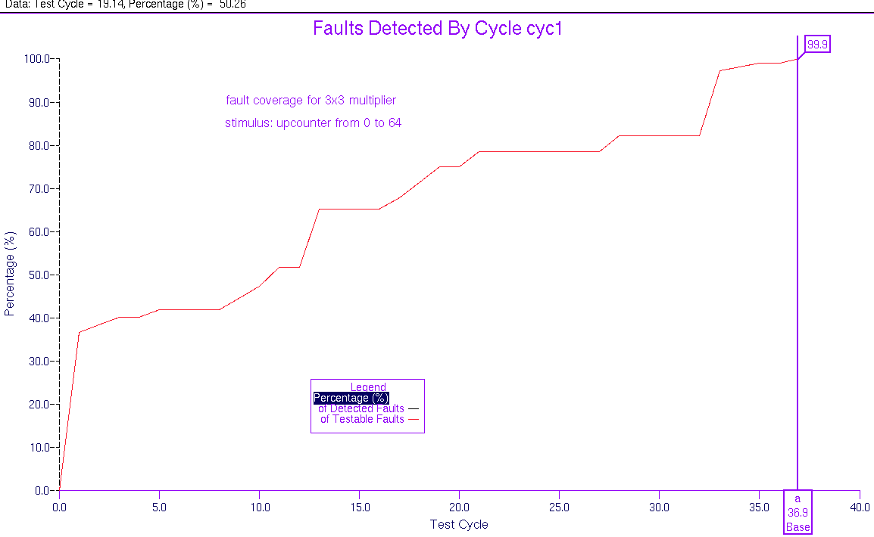
Figure VI-4, Fault coverage (%) vs. test cycle plot for 3x3 multiplier

On the other hand, as seen in the histogram plot in figure VI-5, although you cannot easily observe the total fault coverage up to a certain cycle, the effect of each individual cycle is very clearly displayed, which is extremely hard to observe from the plot in figure VI-4. Moreover, another information easily obtained from the histogram is the redundant cycles within the first 37 cycles and the cycles which are very effective in fault detection, i.e. the cycles that produce strong peaks in histogram, which are also quite obscure in the plot. In our case, there are only 17 out of the 37 cycles which are actually effective in fault detection, and cycles 13 (001101) and 33 (100001) are seen to be very effective in this order of input patterns.

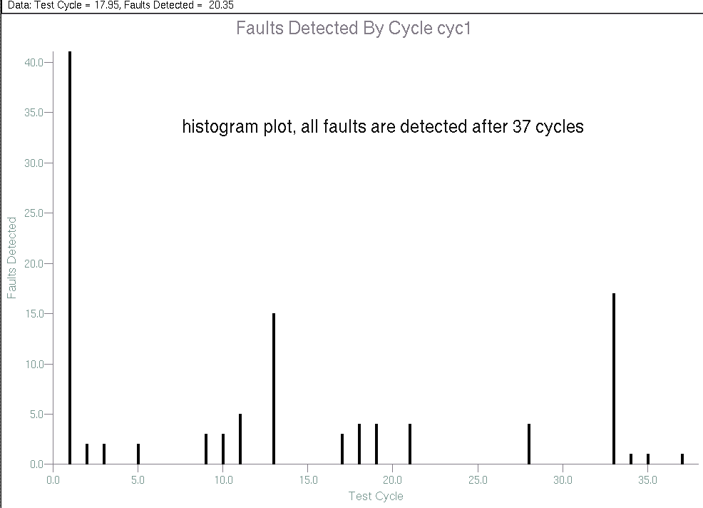
Figure VI-5, Number of Detected Faults vs. test cycle histogram for 3x3 multiplier

Obviously, these two statistics are very elucidating and reveal several guiding information. Fault coverage plot can reveal the amount of required patterns to achieve a certain lower limit on fault coverage, while histogram can be used to determine effective starting points for the BIST circuit – as made use of in seed determination for LFSRs and CA – and to determine an efficient set of deterministic test patterns. Hence, as the cycle based test is performed such that, each strobe is for 1 test pattern, the terms test cycle and test pattern are used loosely interchangeably throughout the text. As can be deduced from Appendix D-1, the histogram and plot data can also be extracted from the fault list data after simulation. Therefore, for batch simulation, or to perform fault simulation from a remote machine without graphics interface, the text data written in the fault list can be used to independently plot the histogram and fault coverage plot.

From now on, the fault lists, input stimuli and cycle info data will not be included in the report, as they are rather auxiliary information. However, all the fault simulation data is also included in the “CD>MSc/Results/”. From here on, until the inclusion of BIST circuit in the synthesized hardware, all the fault simulation results are in “CD>MSc/Results/mult8x8/”. The fault simulations after the inclusion of designed BIST hardware are referenced from the design name, as “CD>MSc/Results/DesignName”. The standard naming convention for the fault simulation data is as shown in table 13:

Stimuli | CD>MSc/Results/mult8x8/appliedBIST/appliedBISTstimulus.txt
Schematic Level Simulation Results | CD>MSc/Results/mult8x8/appliedBIST/appliedBISTsim.gif
Schematic Level Simulation Results | CD>MSc/Results/mult8x8/appliedBIST/appliedBISTsimlist.txt
Fault Lists | CD>MSc/Results/mult8x8/appliedBIST/appliedBISTfaultlist.txt
Cycle Infos | CD>MSc/Results/mult8x8/appliedBIST/appliedBISTcycleinfo.txt
Fault Grades | CD>MSc/Results/mult8x8/appliedBIST/appliedBISTfaultsummary.txt
Fault Coverage Plots | CD>MSc/Results/mult8x8/appliedBIST/appliedBISTplot.gif
Histograms | CD>MSc/Results/mult8x8/appliedBIST/appliedBISThisto.gif
Table 13, Fault simulation data locations in CD

Moreover, the plots included in the text are also stored in:
“CD>MSc/DesignFiles/report/quickfaultfigs”, but it is recommended that the figures in the Results/ are preferred as the report figures are color edited and have worse resolution.

VI.3 – BIST for 8x8 Multiplier

Having described the design flow and general data structure with Initiation parts I and II, we start the investigation of BIST techniques for the 8x8 multiplier, designed in Renoir, using the parameterized multiplier. The synthesized 8x8 multiplier is in:
“CD>MSc/DesignFiles/Renoir/Eddm_schematic/ cpamultnxn_8/”.

Initially we use board level faulting for the fault simulation of 8x8 multiplier, and then we revert to the hierarchical fault injection using the generic library ($MGC_Genlib) of Renoir as the hierarchical leaf level, which includes only AND, OR gates, inverters, set-reset flip-flops, etc., which is a very low level hierarchical model compared to the models most vendors provide. Several well-practiced and original BIST techniques are applied as stimuli and their fault coverage performances are observed, with specific emphasis given on PRBS generation schemes. Repeated patterns, which are shown to provide very high fault coverage with a small set of input test vectors([3]) are observed and used within PRBS generation structures.

During the investigation of different BIST schemes, we use automatically generated stimulus files, either created from QuickFault or using the Matlab Scripts in “CD>MSc/DesignFiles/matlab”. With the quick turnover of this approach, various techniques are investigated without the necessity of building the BIST hardware. After we conclude the investigation and decide upon the BIST structure based on the observed performances, we move back to design entry phase and generate the blocks required for the BIST circuit. The next step is the investigation of output compression techniques and comparison of the fault coverage results with and without output compression.

VI.3.1 – BIST = 16 bit Upcounter for Board Level Faulting:
As the first probable BIST scheme, we use an upcounter of 16 bits length, which produces all the possible 2¹⁶ = 64K = 65536 input patterns for the multiplier. With board level faulting, the number of injected faults is 932 and we apply exhaustive testing for all 64K input patterns. From the experience gained by the fault simulation of 3x3 multiplier with the same upcounter scheme, we expect again around 40% of the overall exhaustive test to be redundant.

The applied stimulus is in “CD>MSc/Results/mult8x8/upcountstimulus.txt” and the fault list for the inserted faults is in “CD>MSc/Results/mult8x8/faultlist.txt” and the test cycle information is in “CD>MSc/Results/mult8x8/cycleinfo.txt”. The schematic generated for the 8x8 multiplier and the injected faults are as shown in figure VI-6, which also displays an exemplary schematic level simulation for the multiplier with the inputs and output in signed decimal radix. From now on, for all the stimuli, one pattern duration is 100 ns, and strobing time is 90 ns.
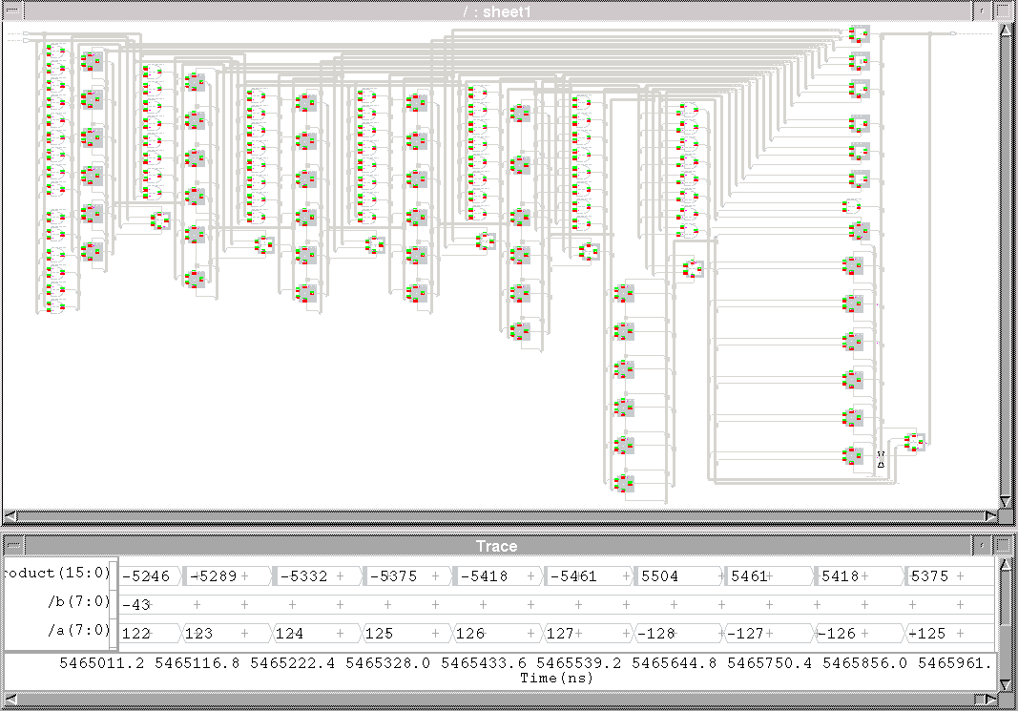
Figure VI-6, Multiplier 8x8 Schematic, Inserted Faults and Simulation trace for the upcounter test

With the applied stimulus, 100% fault coverage is achieved in 32897 cycles out of 64K. Exceeding our expectation, the redundancy is around 50 %, and the last effective input pattern is: 32897-1₁₀ = 32896₁₀ = 10000000 10000000₂, which is the most negative value possible multiplied by itself. The grade of the fault simulation is as shown below:
--------------
Total Faults : 932
Unsimulated Faults : 0

RESULTS FROM LAST RUN
---------------------
Run Time : 5466000.0ns
Total Faults : 932
Untestable Faults : 0
Testable Faults : 932
Undetected Faults : 0 (0.00%)
Detected Faults : 932 (100.00%)
Possible Faults : 0 (0.00%)
Hyperactive Faults : 0 (0.00%)
Hypertrophic Faults : 0 (0.00%)
Oscillatory Faults : 0 (0.00%)
HM Dropped Faults : 0 (0.00%)

The histogram and the fault coverage plot are as shown in figures VI-7 and VI-8 respectively.

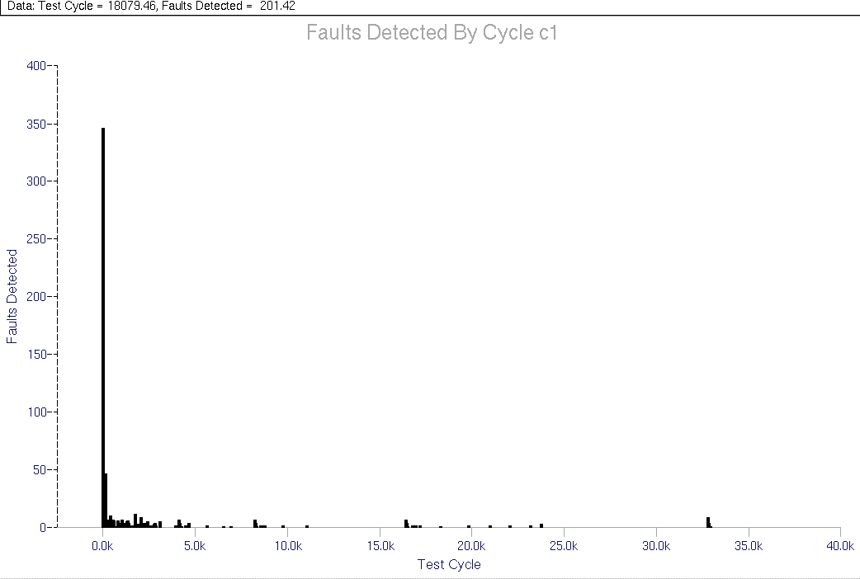
Figure VI-7, Number of Detected Faults vs. test cycle histogram for board level upcount test

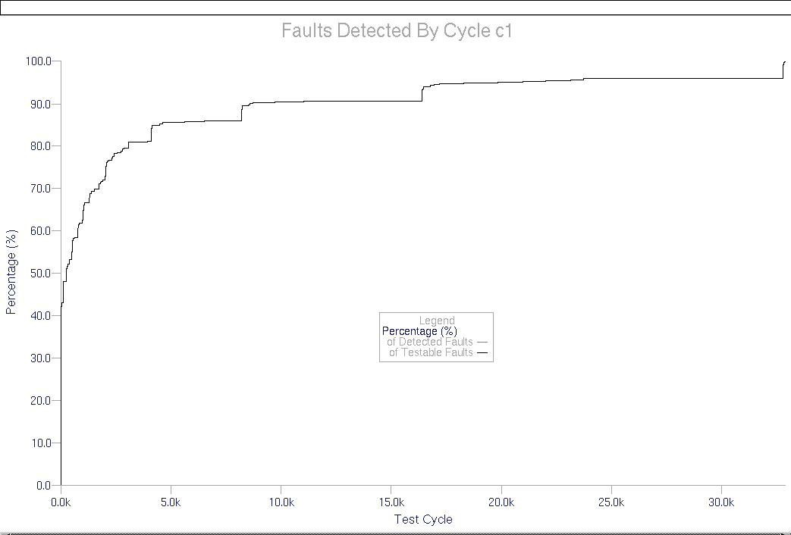
Figure VI-8, Fault coverage (%) vs. test cycle plot for board level upcounter test
As can be seen in histogram, there is a vast redundancy within the 32897 cycles as well. After the initial hyperactive region, the cycles that are effectively detecting faults are distributed within the 32897 cycles. The only seemingly nonredundant region is right at the end of the displayed patterns where a set of consecutive patterns actively detect remaining faults.

The plot, after the initial steep increase in fault coverage, shows an almost flat incline and then, a step like jump at regions around 4K, 8K, 17K and 33K where the effective cycles are seen to concentrate.

VI.3.2 – BIST = 16 bit Downcounter for Board Level Faulting:
Similar to first BIST, we use a downcounter of 16 bits length, which produces all the possible 2¹⁶ = 64K = 65536 input patterns for the multiplier. We use board level faulting (932 faults) and apply the test for all 64K input patterns in the reverse order of previous section. All the fault simulation data are in “CD\MSc\Results\mult8x8\downcount”. With the same strobing setup, we achieve 100% fault coverage exactly at 32897th cycle again. The fault grade is as shown below:

CURRENT STATUS
--------------
Total Faults : 932
Unsimulated Faults : 0

RESULTS FROM LAST RUN
---------------------
Run Time : 4000000.0ns
Total Faults : 932
Untestable Faults : 0
Testable Faults : 932
Undetected Faults : 0 (0.00%)
Detected Faults : 932 (100.00%)
Possible Faults : 0 (0.00%)
Hyperactive Faults : 0 (0.00%)
Hypertrophic Faults : 0 (0.00%)
Oscillatory Faults : 0 (0.00%)
HM Dropped Faults : 0 (0.00%)

The acquired histogram and fault coverage plot are as in figures VI-9 and VI-10 respectively.

As can be observed from the plots, the fault coverage builds up much rapidly than the upcounter. However, it still requires a huge 32897 patterns to achieve 100% fault coverage. The histogram is also much less spread providing much better concentrated set of patterns for large amount of fault detection.
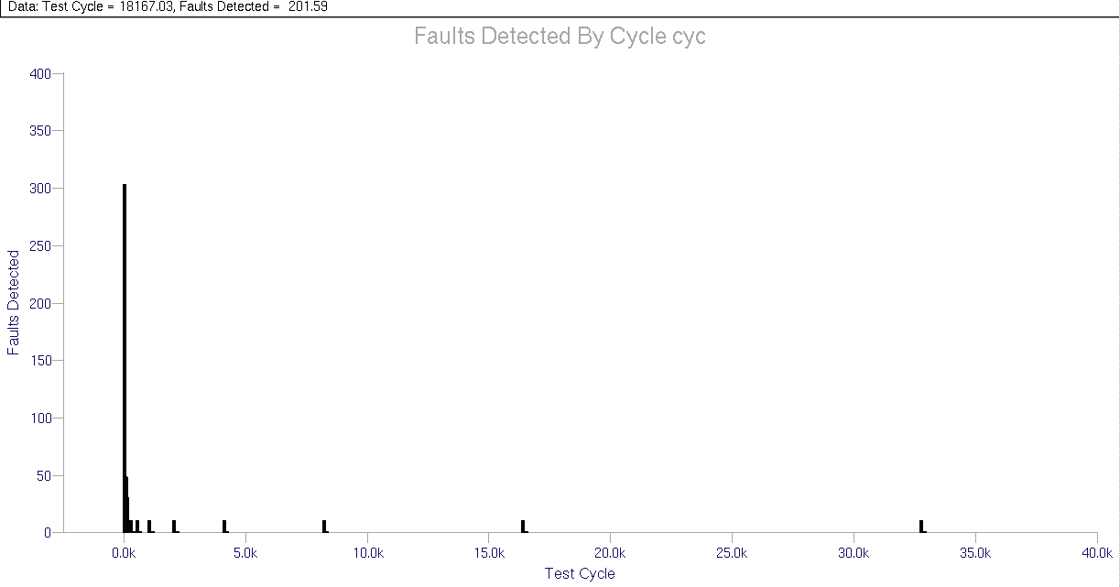
Figure VI-9, Number of Detected Faults vs. test cycle histogram for board level downcount test
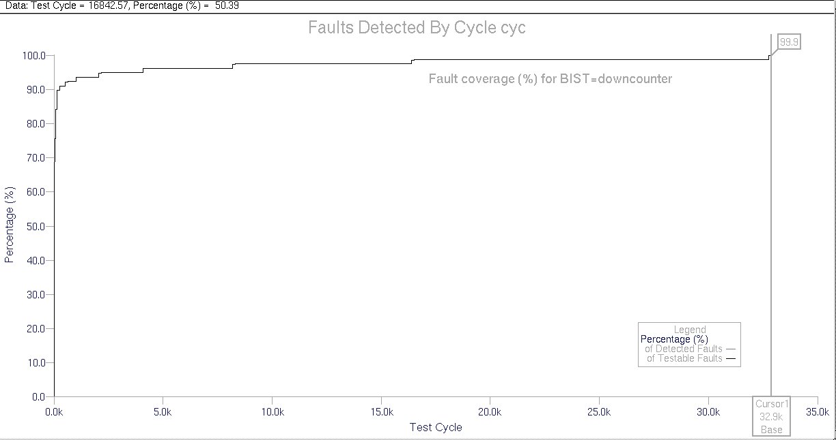
Figure VI-10, Fault coverage (%) vs. test cycle plot for board level downcounter test

VI.3.3 – BIST = 16 bit Rolling 0 for Board Level Faulting:
Although the above two cases demonstrate the case of full exhaustive testing, with the probably simplest BIST to be thought, they also produce very discouraging results as for only 932 faults, which are at the highest level, around 32000 vectors are needed for full coverage. And as seen in the histograms, more than 90% of the vectors are actually redundant and applied only to follow the BIST sequence. As a matter of fact, for 932 faults, much less than 932 vectors must suffice for fault coverage, as number of vectors being more than number of faults inherently signals inevitable redundancy.

At this point, a careful observation of the multiplier circuit reveals an important phenomenon. All the 16 inputs of multiplier are first applied to either to HLandH gates (for MSB partial products) or to HHandH gates (for all other partial products), and then, the number of inputs is reduced to half. Intuitively, a test set that fully exercises the multiplier, should start by fully exercising these input gates and then cleanup tests might be applied for the remaining faults. However, the challenge is to provide this scheme in BIST rather than as a standalone deterministic test set. Considering the AND structure of the input gates, a rolling 0 test pattern as demonstrated in table 14 for the 16 bit inputs seems promising, as for an AND gate, to test the input and output pins for stuck at 1 and stuck at 0, a 01→ 10 → 11 pattern is sufficient, which is produced for all the gates with the rolling 0 pattern.

Rolling zero:
11…110
11…101
•
•
01…111
16 bits per pattern
Total 16 patterns

Table 14, Rolling 0 pattern
In order to verify this argument, the rolling 0 pattern, which is quite easy to generate as BIST, is applied as the next test set. The simulation data are in “CD\MSc\Results\mult8x8\rolling0”. As seen in the fault grade, there is 98.07% fault coverage, with only these 16 vectors. Out of the 932 board level faults, 914 are detected and only 18 of the injected faults are undetected. The histogram and fault coverage plots, in figures VI-11 and VI-12 reveal the very efficient impact of each vector and the fault coverage curve is almost piecewise linear, without any flat regions that imply redundancy. In order to have an understanding of the undetected faults, we also demonstrate the undetected faults on the circuit after the application of the rolling 0 test pattern in figure VI-13. As can be seen on the figure, undetected faults are on the MSB bits of the partial adders and on the noninverted inputs of the HLandH gates. This latter observation as zoomed on figure VI-13 is also displayed on figure VI-14.
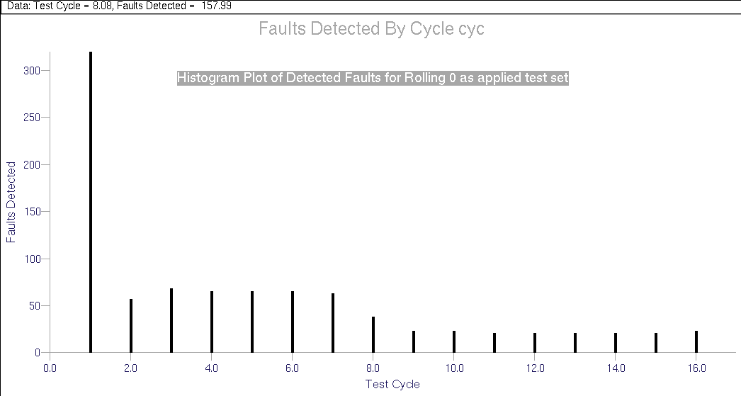
Figure VI-11, Histogram for board level rolling0 test

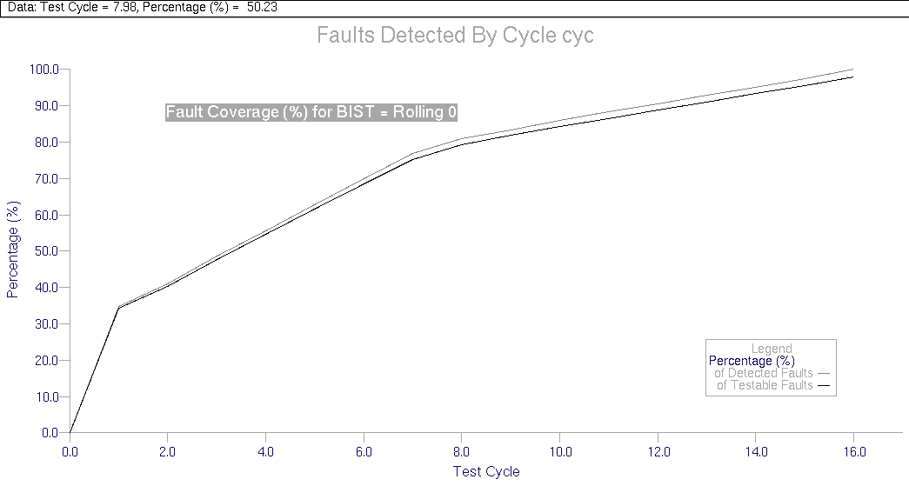
Figure VI-12, Fault coverage (%) for board level rolling0 test
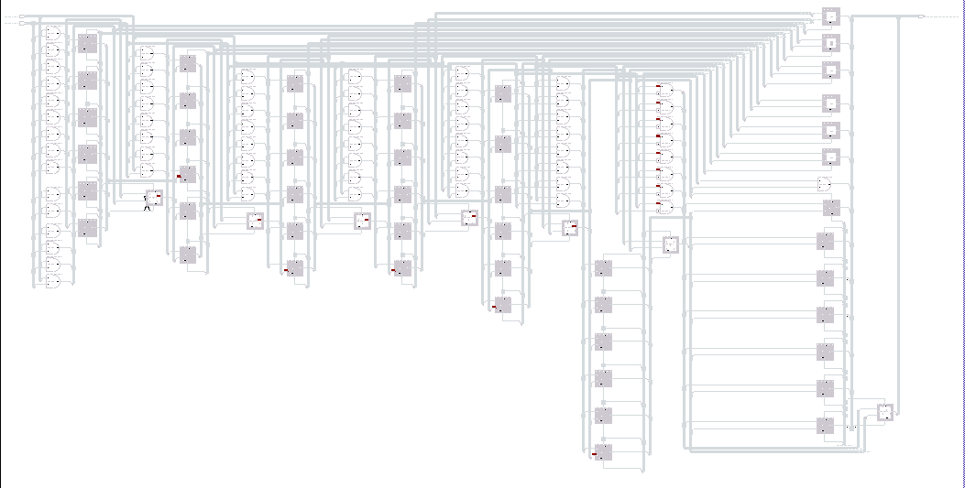
Figure VI-13, Undetected faults
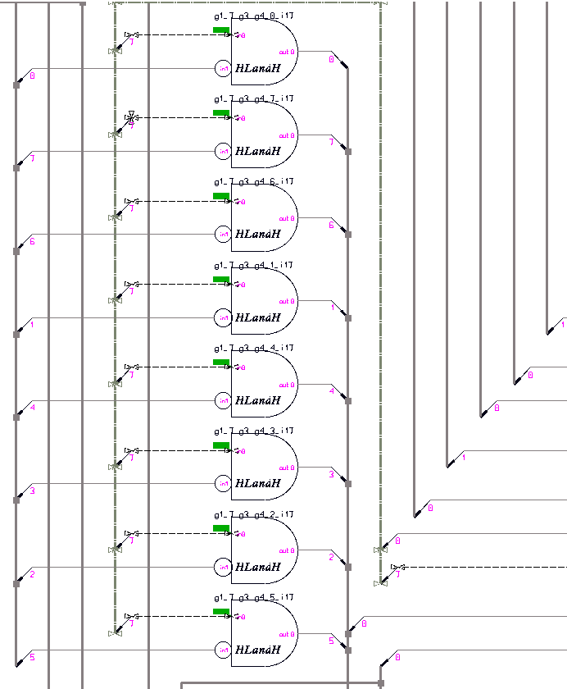
Figure VI-14, Undetected faults on the HLandH gates

Figures VI-13 and VI-14 provide two important observations:
- 8 out of 18 undetected faults are on the noninverted inputs of the HLandH gates
- all the undetected faults are stuck at 1 faults

These both imply addition of a zero dominated input test vector, which is the discussion of the next section.

VI.3.4 – BIST = 16 bit Rolling 0 + all 0s for Board Level Faulting:
The actually expected reason for the undetected faults on the HLandH gates is evident. For a stuck at 1 fault at the noninverted input terminal of the HLandH gate to propagate to the output, the other input should be true so that the output is sensitized with respect to the noninverted input. To provide a conflict at output, the stuck at 1 test should apply a zero to the tested input. These two facts, which are visualized in figure VI-15 require a 00 pattern at each HLandH gate input, which can be accomplished with an all 0s test pattern in parallel for all the gates. Moreover, there is good chance that this all 0s pattern will also detect the other stuck at 1 faults as only 0s are propagated through the circuit components. Consequently, due to the second observation stated, the circuit has the probable opportunity of being completely tested for the injected faults.
S@1??
0
0

Figure VI-15, Sensitization of noninverting input for stuck at 1 fault

With the inclusion of all 0s, overall test set now becomes as shown in table 15, which can also be generated on chip with simple hardware.

Rolling zero + all 0s:
11…110
11…101
•
•
01…111
00…000
16 bits per pattern

Total 17 patterns

Table 15, Rolling 0 + all 0s pattern

All the fault simulation data and the corresponding results for this BIST are in “CD\MSc\Results\mult8x8\rolling0andall0”. A snapshot of the overall fault simulation is as shown in figure VI-16, where the rolling 0 and final all 0s case is demonstrated and the resulting fault grade is shown below:

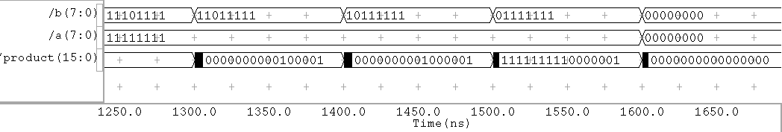
Figure VI-16, Fault simulation for rolling 0 + all 0s

CURRENT STATUS
--------------
Total Faults : 932
Unsimulated Faults : 0

RESULTS FROM LAST RUN
---------------------
Run Time : 1700.0ns
Total Faults : 932
Untestable Faults : 0
Testable Faults : 932
Undetected Faults : 0 (0.00%)
Detected Faults : 932 (100.00%)
Possible Faults : 0 (0.00%)
Hyperactive Faults : 0 (0.00%)
Hypertrophic Faults : 0 (0.00%)
Oscillatory Faults : 0 (0.00%)
HM Dropped Faults : 0 (0.00%)

As seen in the grade, all the faults are detected and 100% fault coverage is achieved with just 17 vectors, which are easily produced with a simple BIST scheme. This result is extremely promising compared to the 32897 test patterns of the upcounter and downcounter cases. The achieved histogram and fault coverage plots are also shown in figures VI-17 and VI-18.
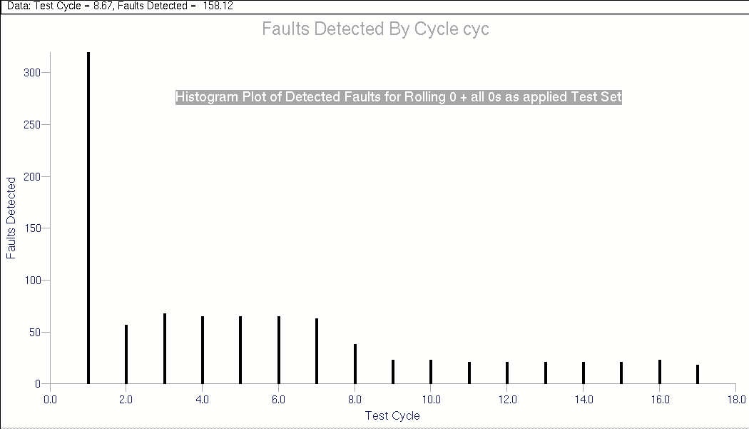
Figure VI-17, Histogram for board level rolling0 + all 0s test
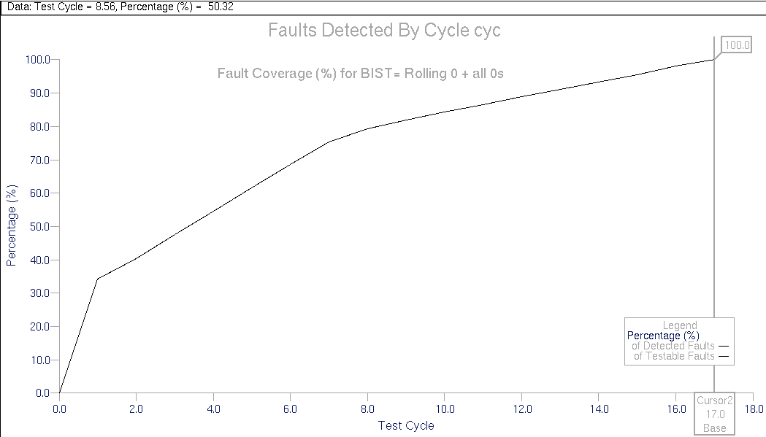
Figure VI-18, Fault coverage (%) for board level rolling0 + all0s test

Although this result seems to have concluded the BIST investigation with an extremely efficient test scheme, one shortcoming discussed previously must be reconciled. The use of board level faulting is very abstract and the results are prone to criticism. Therefore, as a very important milestone in the project, we move forward to hierarchical faulting and verify our results with the new fault models.
VI.4 – BIST for 8x8 Multiplier with Hierarchical Faulting

In section VI.3.4, we have found very promising results for the BIST pattern to use for fault testing of the 8x8 multiplier. However, one drawback of the fault simulation technique used was the over-optimistic results of board level faulting as the assumed flawless models are then full adders, half adders etc. some of which are too complex to consider as the primitive blocks. Unfortunately, this is one controversy of fault simulation, as there can be no standard in the selection of primitives as each vendor supplies a different set of primitive blocks, which also makes the compressions between two different fault simulation results by two different parties very cautious to compare. As there is no fixed standard in selection of primitives in fault simulation, the next decision to be made in the project was the selection of the primitives to be used. Considering the board level simulation at one extreme of complexity, we moved to the other possible extreme, the most detailed block level, where the primitives are AND, OR, NOT gates, flip-flops , etc. This was, though over-pessimistic, a thoroughly robust approach as any other model in between of the two extremes would always carry a sign of possible criticism in the fault simulation.

With the described primitive levels, we performed hierarchical fault injection to the 8x8 multiplier circuit, and the total number of injected faults exploded from 932 to 6008, which are displayed on the multiplier schematic in figure VI.19. An immediate difference from the board level faulting as shown in figure VI.6 is the description of faults inside each higher level block which are displayed as up – for stuck at 1 – and down – for stuck at 0 – arrows on the blocks with the number of injected faults written inside the arrows. In order to present the injected errors in the lower hierarchies, each of the higher level blocks are zoomed on figure VI-19 and are printed separately in figures VI-20 to VI-24. As seen in the zoomed figures, the FA and MSBFA circuits have more than 100 faults per instance and therefore have several lower level nodes that can have a stuck at fault.
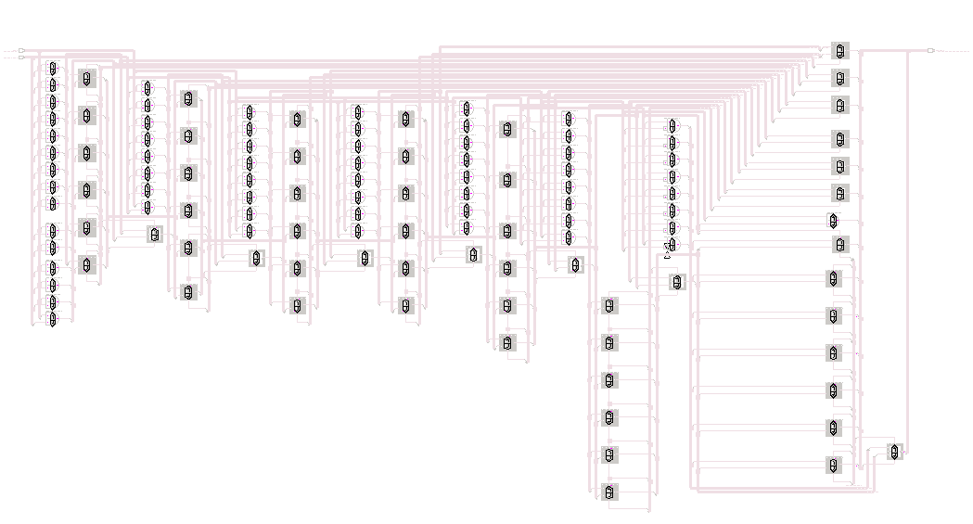
54+54 = 108 faults for each MSBFA ➔ figure V-20

54+54 = 108 faults for each FA ➔ figure V-21

16+16 = 32 faults for each HA ➔ figure V-22
3+3 = 6 faults for each HHandH gate ➔ figure V-23

5+5 = 10 faults for each HLandH gate ➔ figure V-24

Figure VI-19, Hierarchical Fault injection

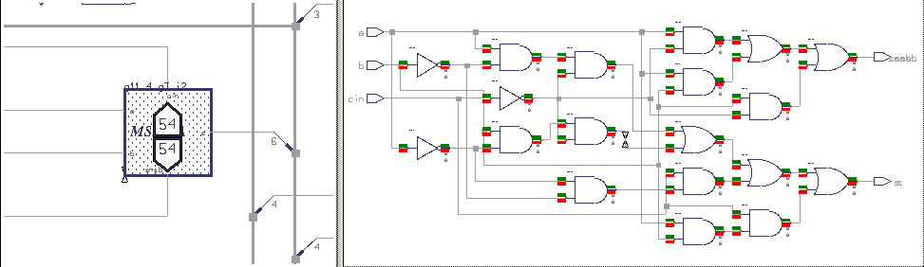
Figure VI-20, Faults inserted to MSBFA

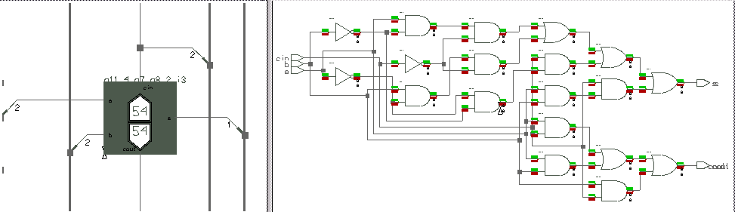
Figure VI-21, Faults inserted to FA

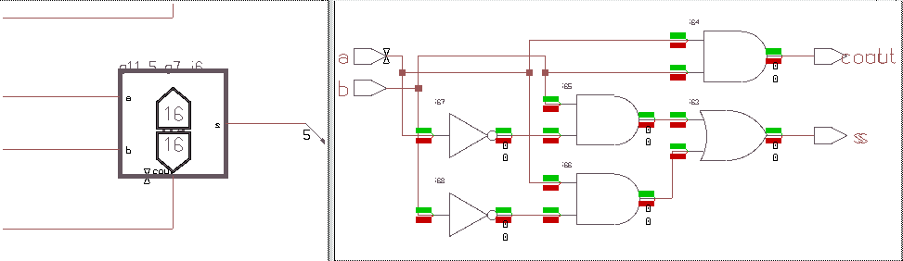
Figure VI-22, Faults inserted to HA

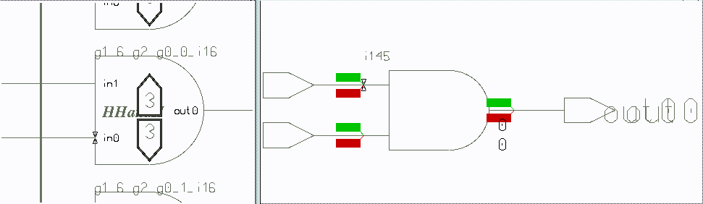
Figure VI-23, Faults inserted to HHandH gate

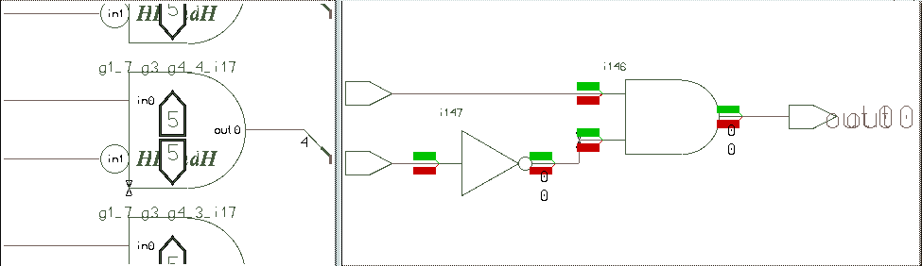
Figure VI-24, Faults inserted to HLandH

Hence, from this point on in the report, all the mentioned BIST techniques are evaluated using hierarchical fault simulation.

VI.4.1 – BIST = 16 bit Rolling 0 + all 0s:
Recalling from section VI.3.4, we had accomplished a 17 vector almost perfect BIST pattern for fully testing the 8x8 multiplier for the 932 board level faults. Now to alleviate any kind of criticism, we perform the same BIST simulation, for the 6008 hierarchical faults. Unfortunately, as the fault grade reveals below, the BIST pattern can detect only 4903 of 6008 patterns with hierarchical faulting.

CURRENT STATUS
--------------
Total Faults : 6008
Unsimulated Faults : 0

RESULTS FROM LAST RUN
---------------------
Run Time : 1700.0ns
Total Faults : 6008
Untestable Faults : 0
Testable Faults : 6008
Undetected Faults : 1105 (18.39%)
Detected Faults : 4903 (81.61%)
Possible Faults : 0 (0.00%)
Hyperactive Faults : 0 (0.00%)
Hypertrophic Faults : 0 (0.00%)
Oscillatory Faults : 0 (0.00%)
HM Dropped Faults : 0 (0.00%)

All the fault simulation data and results are in
" CD/MSc/Results/mult8x8/rolling0andall0/hierarsikSim/"

The corresponding fault coverage plot and histogram are shown in figures VI-25 and VI-26, as seen, although the detection is very efficient, the 17 vectors cannot suffice for a high fault coverage for the 6008 faults. Consequently the fault coverage resides at 81.6 %, which is a very unacceptable result, meaning 1 in every 5 of the circuit faults will pass the test undetected. These disappointing results cause the proposed rolling 0 & all 0s to be removed back to shelf and either new methods or effective improvements on this test must be seeked. An observation of the remaining faults (which are in "MScCD/MSc/Results/ /mult8x8/rolling0andall0/hierarsikSim/hierarsikfaultlist.txt" in accordance with the consistent filing) reveals that all the faults in HA, HHandH and HLandH are detected and that, the undetected faults increase toward the significant bit adders.

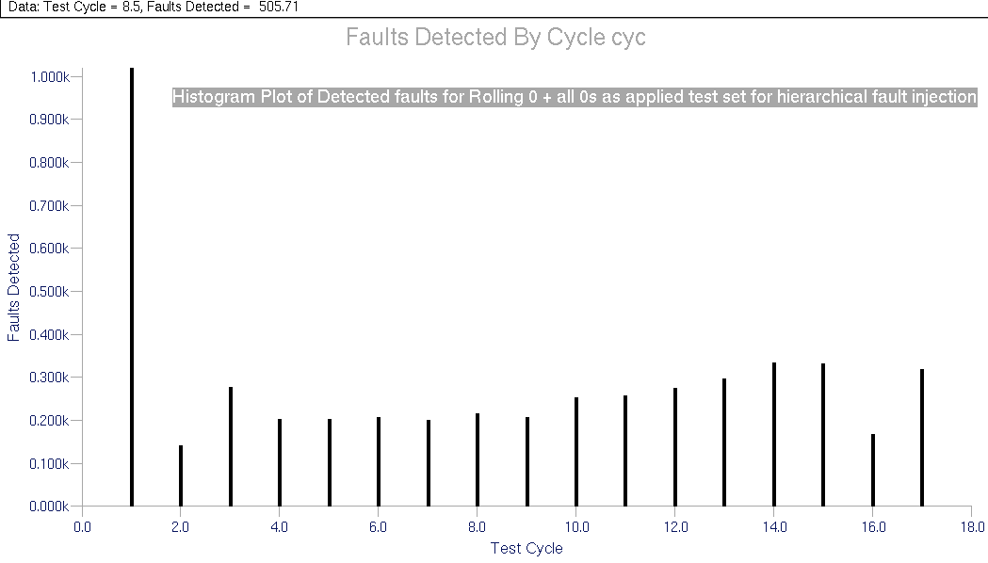
Figure VI-25, Histogram for hierarchical rolling0 + all 0s test

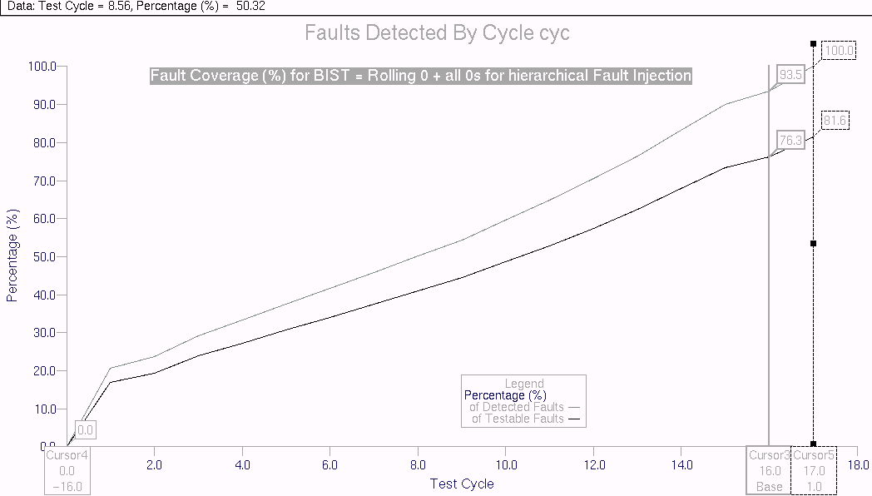
Figure VI-26, Fault coverage (%) for hierarchical rolling0 + all0s test

As the first rescue to the reduced fault coverage, we try to improve the test with several alternatives. Adding a "11…11" sequence is seen to have no effect on fault coverage, while a rolling 1 sequence, described in table 16, provided very low improvement as shown in figure VI-27.

Rolling one:
00…001
00…010
•
•
10…000
16 bits per pattern
Total 16 patterns

Table 16, Rolling 1 pattern

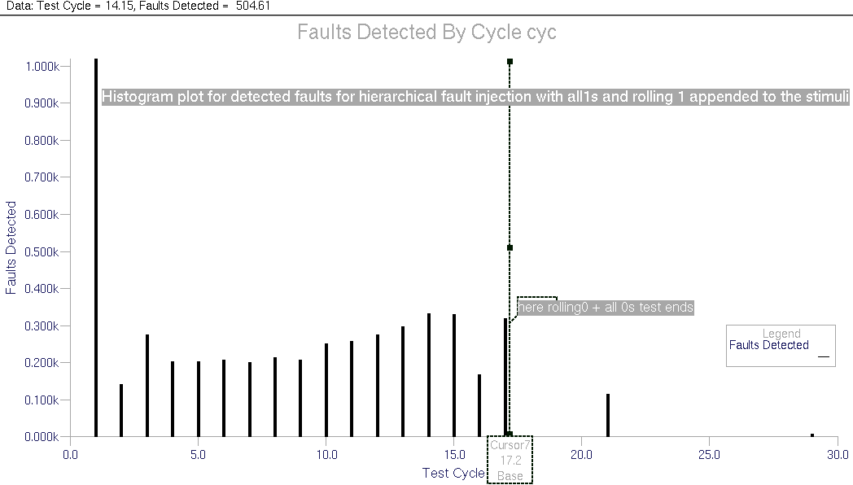
Figure VI-27, Histogram for rolling0 + all 0s test followed by a rolling1 test

Figure VI-27 is a very demonstrative histogram as it displays how ineffective the second test is compared to the first one. These and several other attempts all revealed similar behavior and any kind of postfix on the rolling 0s and all0s test are verified to be ineffective. Then, as a second hope of remedy, other modifications of the test are tried and fault simulations for these tests also revealed slight to no improvements on fault coverage.

For brevity, two of these proposed modifications that are tested are presented below and the corresponding test data are referred from the CD.

Two Rolling 0s: A modification, suggested by Prof. Morling is applying two 8 bit wide rolling 0 sequences in parallel to the a & b inputs of the multiplier. The suggested test set is described in table 17. The test simulation data and resulting histogram and fault coverage plots as well as simulation trace plot and simulation list are in:
" CD/MSc/Results/mult8x8/tworolling0s/hierarsiksim/"

8 bits per pattern
Rolling zero for a: | Rolling zero for b:
11…110 | 11…110
11…101 | "
• | "
• | "
01…111 | "
11…110 | 11…101
11…101 | "
• | "
• | "
01…111 | "
• | •
• | •
11…110 | 01…111
11…101 | "
• | "
• | "
01…111 | "

8 patterns of a for each b pattern

Total 64 patterns

Table 17,Two Rolling 0s pattern

The resulting fault grade is:
CURRENT STATUS
--------------
Total Faults : 6008
Unsimulated Faults : 0

RESULTS FROM LAST RUN
---------------------
Run Time : 6500.0ns
Total Faults : 6008
Untestable Faults : 0
Testable Faults : 6008
Undetected Faults : 729 (12.13%)
Detected Faults : 5279 (87.87%)
Possible Faults : 0 (0.00%)
Hyperactive Faults : 0 (0.00%)
Hypertrophic Faults : 0 (0.00%)
Oscillatory Faults : 0 (0.00%)
HM Dropped Faults : 0 (0.00%)

Although this result improves fault coverage to 87.9 %, it is still a very low fault coverage. Further additions appended to this set such as a "11…11" sequence at the end seems to improve the performance insignificantly.

Two Rolling 0s + all 1s for each b pattern: This second alternative was considered as the first alternative does not completely cover the rolling 0s and all 0s sequence, as there are two zeros per pattern except for all 0s and all 1s sequences. To cover the single rolling 0s pattern, an all 1s 8 bit pattern is added at the end of each 'a' pattern – counting up to 9 patterns per b pattern now – and a separate all 1s b pattern is also included. This new pattern is described in table 18, and comparing with table 17, the additions are highlighted for easy observation.

8 bits per pattern
Rolling 0 + all 1s for a: | Rolling 0 + all 1s for b:
11…110 | 11…110
11…101 | "
• | "
• | "
01…111 | "
11…111 | "
11…110 | 11…101
11…101 | "
• | "
• | "
01…111 | "
11…111 | "
• | •
• | •
11…110 | 01…111
11…101 | "
• | "
• | "
01…111 | "
11…111 | "
11…110 | 11…111
11…101 | "
• | "
• | "
01…111 | "
11…111 | "

9 patterns of a for each b pattern

Total 81 patterns

Table 18,Two Rolling 0s + all 1s for each b pattern

Once again, this alternative is also observed to improve fault coverage insignificantly. Moreover, as can be observed from the last 3 tables, the complexity of the generated pattern is also becoming more complex with the new modifications and add-ups. As result of all these, with great regret, we drop the rolling 0 test as the ultimate BIST proposal after the above elaborations for hierarchical faulting.

VI.4.2 – Benchmark BIST = 16 bit Downcounter:
Having observed that faulting level effects the determination of the BIST sequence, we start with a 16 bit fully exhaustive downcounter test, which will serve us as a benchmark when evaluating other strategies. One of the expectations of this fault simulation is to observe that we won't be able to achieve 100% fault coverage with even full-exhaustive testing, as the hierarchical design procedure might inherently involve some untestable nodes at this detailed level. The fault simulation data and results are in:
" CD/MSc/Results/mult8x8/downcount/hierarsiksim/"

The simulation list file:"CD/MSc/Results/mult8x8/downcount/hierarsiksim/ /downcountsimlist.txt" also presents a full simulation of 8x8 multiplier, where the radix are displayed in signed decimal format for easy observation.

As seen in the fault grade ("faultsummary.txt"), the fault coverage is 98.49% after all the possible patterns are applied. Therefore, no test can exceed this value of fault coverage. This also raises one counterargument against Cell Fault Model and Cell Fault Coverage (CFC) described in [3]. It is suggested on [3,p. 947] that single stuck at fault simulation fault coverage values are always larger than the CFC values. However, the CFC value of 99.40% for the 8x8 CPA multiplier given on p. 945 is not even achievable with single stuck at model with the primitives we use. As a conclusion, we disagree with [3] that CFC is always more pessimistic than single stuck at model and we assert that this rather depends on the primitive levels used in hierarchical faulting. As another inconsistency, the Verifault values used for comparison in p. 947 are referred without presenting the used primitive level and therefore should be regarded with caution.  This also reemphasizes the difficulty in comparing two different published materials.

The histogram and fault coverage plots for the downcounter are shown in figures VI-28 and VI-29.

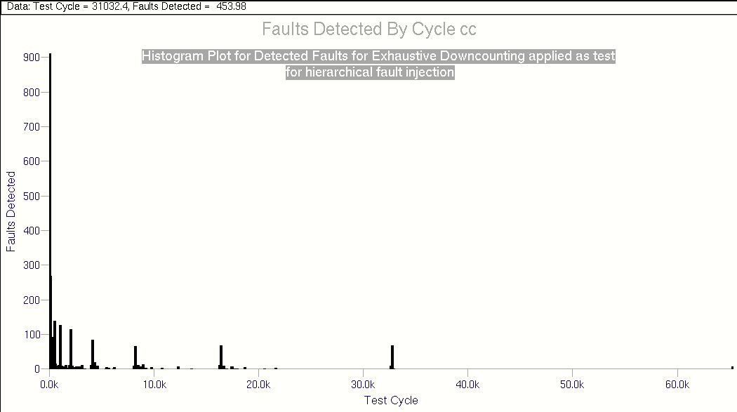
Figure VI-28, Histogram for hierarchical Exhaustive Downcounter test

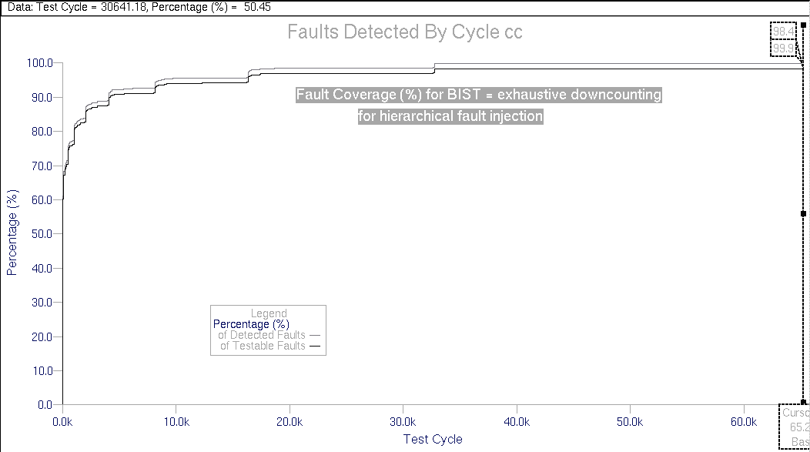
Figure VI-29, Fault coverage (%) for hierarchical Exhaustive Downcounter test

Once again as in previous downcounter test, huge amount of redundancies are observed in both histogram and fault coverage plots. Interestingly, the 32897th sample once again peaks within all other samples. This points to a specific importance of 32897. sample once again. We'll try several new scenarios to reduce these and will try to end up with an efficient, effective, compact test set, which is easy to generate for BIST application. To gain insight to which faults are undetected even with full exhaustive test, we include figure VI-30 which demonstrates the locations of undetected faults.

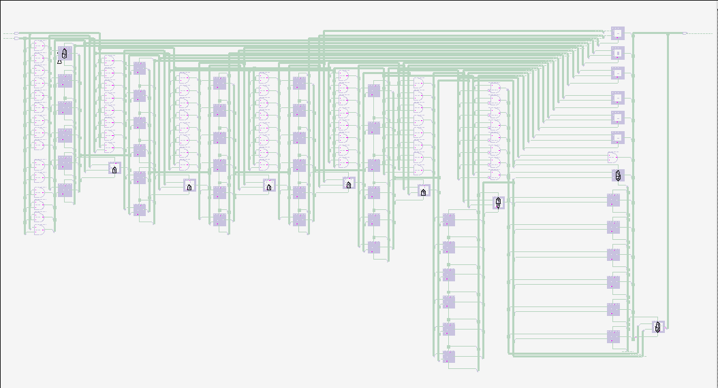
Figure VI-30, Locations of undetected faults for downcounter test in 8x8 multiplier

Interestingly, all the MSBFA adders have invariantly some undetected stuck at 0 faults, which points to a redundancy in the MSBFA design. 

VI.4.3 –BIST = Repetitive Patterns - Upcounter:
Repetitive patterns have been widely used in testing of iterative logic arrays and have been shown to provide excellent fault coverage with a small test set ([3],[5],[23]). For the multiplier, the a and b inputs of multiplier are applied the same patterns for every k inputs where k is the defined "repetition length". If we apply the same pattern to both lower and higher 4 bits of one of the 8 bit inputs in our 8x8 multiplier, the repetition length of this pattern is 4. To verify the effectiveness of repetitive patterns we apply a BIST scheme with a repetition length of 4 and an 8 bit upcounter chosen as input pattern generator. The corresponding input test vectors are then as shown in table 19.

a: |  | b:
a(7:4) | a(3:0) | b(7:4) | b(3:0)
0000 | 0000 | 0000 | 0000
0001 | 0001 | " | "
• | • | " | "
• | • | " | "
1111 | 1111 | " | "
0000 | 0000 | 0001 | 0001
0001 | 0001 | " | "
• | • | " | "
• | • | " | "
1111 | 1111 | " | "
• |  | •
• |  | •
0000 | 0000 | 1111 | 1111
0001 | 0001 | " | "
• | • | " | "
• | • | " | "
1111 | 1111 | " | "
4*4 bits per pattern

16 patterns of a for each b pattern

Total 256 patterns

Table 19,Two Repetitive pattern with repetition length(k)=4,

and pattern generator→ Upcounter

Hardware consideration for this test set can be finalized with a single 8 bit upcounter as:
b(3:0)&&a(3:0)
and
b(7:4)&&a(7:4)
can be concatenated and the 8 bit counter outputs can be directly connected each of the 8 ports.

With this pattern generation scheme, an excellent fault coverage is achieved with the mere 256 described vectors. As can be referred from:
"CD/MSc/Results/mult8x8/greekbist/hierarsiksim/"

The fault grade reveals a 97.02 % fault coverage and as seen in the histogram and fault coverage plots in figures VI-31 and VI-32, 228 cycles/patterns is sufficient for this coverage. Both the histogram and plot show how effective the test set is, most of the patterns contributing to the fault coverage.

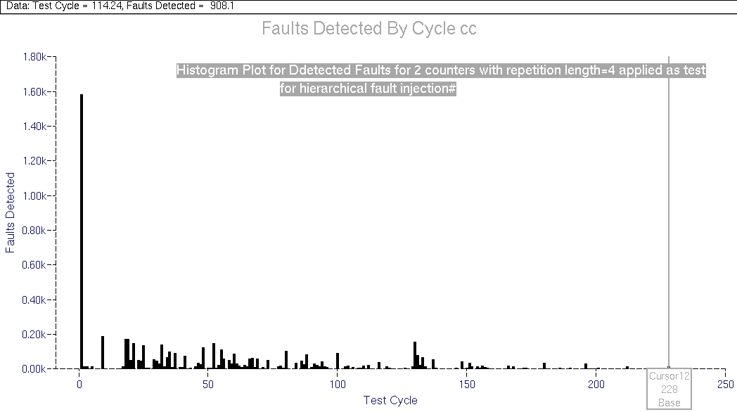
Figure VI-31, Histogram for Repetitive upcounter with k=4

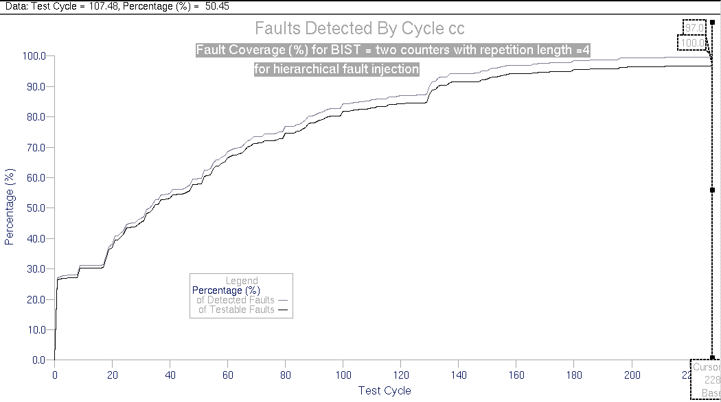
Figure VI-32, Fault coverage (%) for Repetitive upcounter with k=4

Both the histogram and the plot also indicate two other outcomes. There are 2 very ineffective regions right at the start of test, within the first 20 input test vectors and there is a very effective input sequence starting around 127th input test vector. This redundancy observation and peak information, will later be used to even further improve the test set.

This extremely promising result is the best of the achieved so far, and will be considered as the limiting threshold for the following investigations.

VI.4.4 –BIST = 16 bit LFSR:
Moving from deterministic techniques to pseudorandom techniques, we initialize one of the major interests of the project, pseudorandom techniques as BIST for signed parallel multiplier. As the first obvious case to scrutinize we use a 16bit LFSR with seed = x0001, as the hypothetical pattern generation circuit. In order to be able to investigate several LFSR variations, i.e. seed, taps, length, etc., we first wrote a Matlab script that produces the LFSR output and creates an input stimulus file ("dofile in QuickFault") for the multiplier inputs. The first example of the LFSR used with taps at flip-flops 16,5,3,2 for max-length PRBS, is displayed in figure VI-33, with the variable names and indices used in the Matlab script.
D_{in}
_{Qint(16)}
F-F
16
Q(16)
seed(16)
_{Qint(15)}
Q(15)
Q(9)
_{Qint(5)}
F-F
5
Q(5)
seed(5)
_{Qint(4)}
F-F
4
Q(4)
seed(4)
_{Qint(3)}
F-F
3
Q(3)
seed(3)
_{Qint(2)}
F-F
2
Q(2)
seed(2)
_{Qint(1)}
F-F
1
Q(1)
seed(1)
CK
Q(8)
to B(7:0)
to A(7:0)

Figure VI-33,The emulated LFSR by the Matlab Script

The generated Matlab script and the written function bin2hex are in appendix E-2 and also can be referred from “CD>MSc/DesignFiles/matlab”. The generated output stimuli for different seeds are in "CD/MSc/Results/mult8x8/LFSR/LFSR16bit/seedxxxx" directories.

With the first seed = x0001, we performed fault simulation for the 8x8 multiplier. The simulation data and results are in: “CD/MSc/Results/mult8x8/LFSR/LFSR16bit/seed0001/”. With the full exhaustive simulation, the fault coverage reached 98.98%. Unexpectedly, the fault coverage settled above 98.49 %, the value achieved by full exhaustive downcounter test. There is no rational explanation to this as the same vectors are applied with only a different sequence. There are no sequential faults in the combinational circuit and this discrepancy is attributed to the software. The histogram and plot are as in figures VI-34 and VI-35.

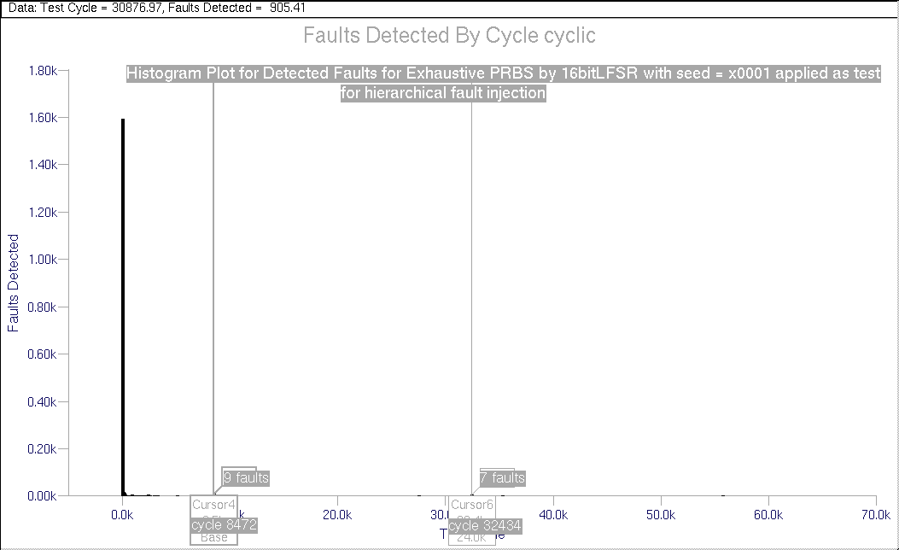
Figure VI-34, Histogram for 16 bit LFSR with seed=x0001

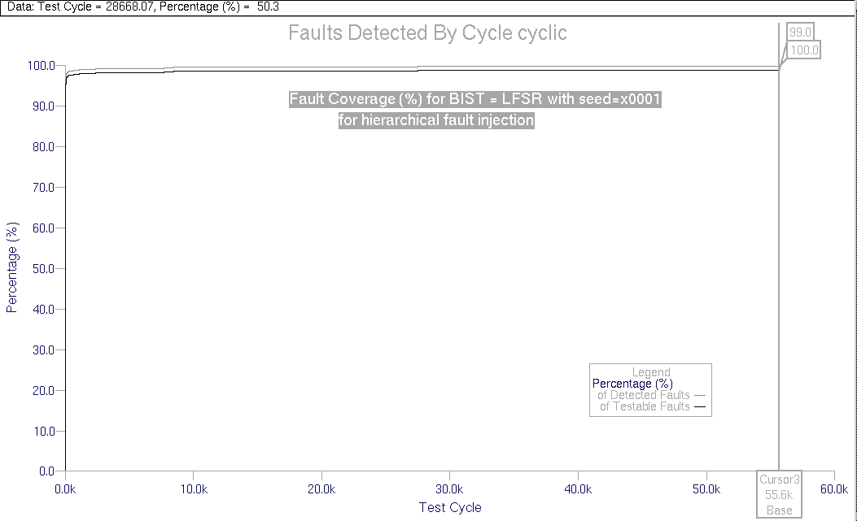
Figure VI-35, Fault coverage (%) for 16 bit LFSR with seed=x0001

As seen in the fault coverage plot, the curve is almost like a step function with almost all faults detected just at the start of the test. We include two more cursors in the histogram in order to demonstrate the cycles with high detection after the hyperactive start phase. These will be used in the determination of seeds for the LFSRs. In order to compare the result with the repetitive upcounter with k=4 in previous section, we zoom at the fault coverage plot to the initial jump, and determine at which cycle fault coverage reaches 97.02%. The zoomed fault coverage plot is shown in figure VI-36.

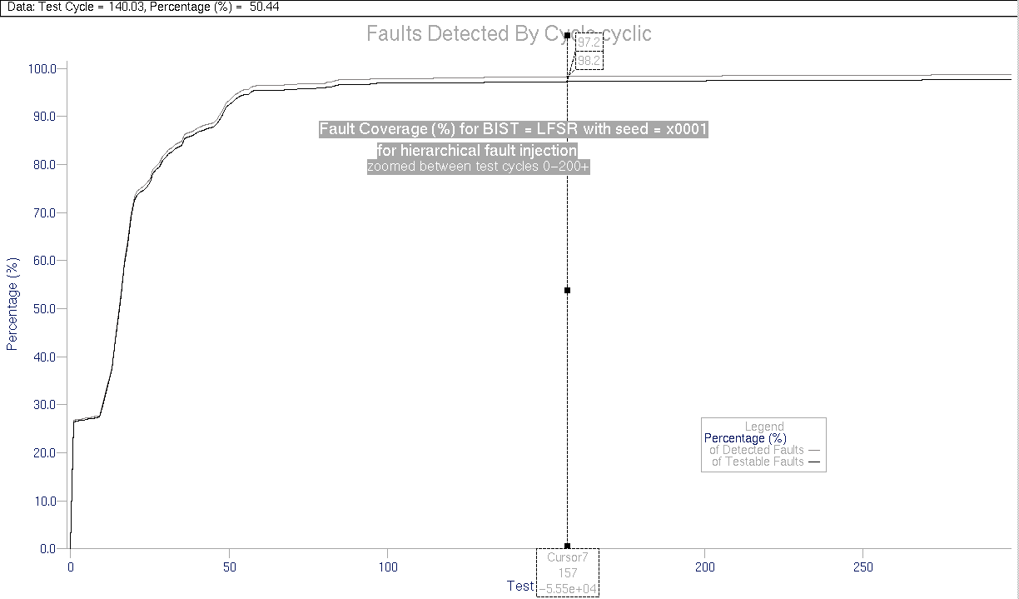
Figure VI-36, Zoomed Fault coverage (%) for 16 bit LFSR with seed=x0001

As seen, with just 157 cycles, the fault coverage reaches 97.2%. We also include a zoomed portion of histogram in figure VI-37 to demonstrate the initial hyperactive phase and to point some of the redundancies in the test. As seen in the histogram, there is a long inactive phase right after start, and then the hyperactivity restarts, which is also indicated by the initial flat region in the zoomed fault coverage curve in figure VI-36. Moreover, the full histogram in figure VI-34 reveals two very important cycles in the detection after the initial phase, as the cursors show, these are cycles 8472 which detects 9 faults and 32434, which detects 7 faults, making the peaks in the almost saturated region of detection. A good methodology for seed determination might then be starting from these values as seed and collapse the initial hyperactive regions with the late peaks.

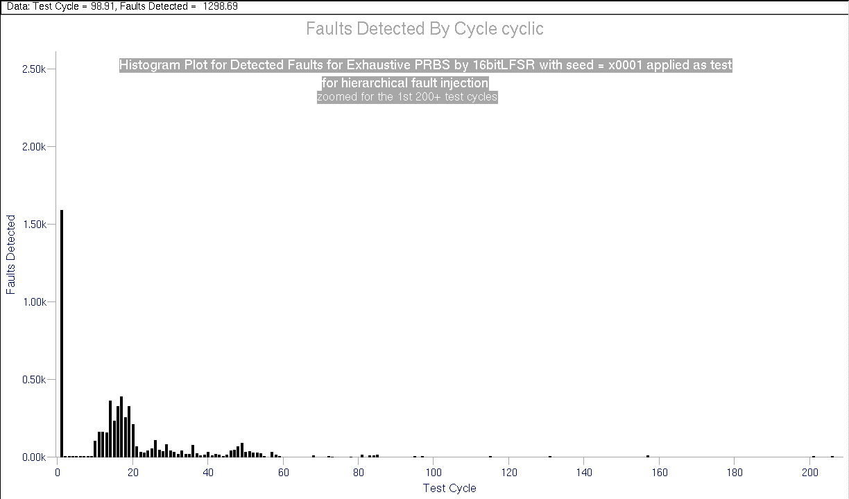
Figure VI-37, Zoomed Histogram for 16 bit LFSR with seed=x0001

As the LFSR lacks the all 0 pattern, we also applied this pattern to the end of test and it is seen to have no effect on fault detection. Therefore, application of DeBrujn counter is not needed to improve performance.

As stated, the two late peaks are used to determine an effective seed for the LFSR. First of these peaks is at cycle 8472, which detects 9 faults. To determine the corresponding LFSR value at this cycle, we determine the simulation time at this cycle and we refer to the simulation list file in:
“CD/MSc/Results/mult8x8/LFSR/LFSR16bit/seed0001/LFSR16bitsimlist.txt”

The corresponding LFSR value is then applied as the seed. For 8472nd cycle, as we strobe the outputs at +90ns after application of each vector:

Simulation time = 8472*100 – 10 = 847190 ns
And from the simlist file:

•
•
846990.0 A9 61 DF09
847090.0 D4 B0 0DC0
847190.0 EA 58 F870
847290.0 F5 2C FE1C
847390.0 7A 96 CD7C
•
•
Time(ns) ^/b(7:0)
^/a(7:0)
^/product(15:0)
➔ seed = B&&A = EA58

Seed = xEA58: With this new determined seed, the performed fault simulation data and results are in: “CD/MSc/Results/mult8x8/LFSR/LFSR16bit/seedEA58/”. The data is not included in the report for brevity except for the zoomed fault coverage plot, which is in figure VI-38.

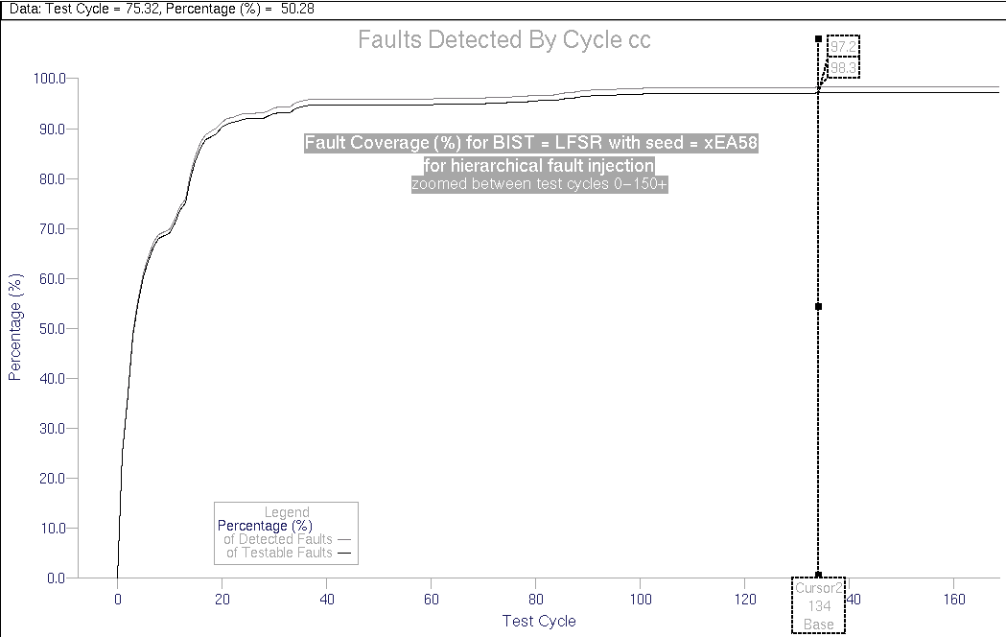
Figure VI-38, Zoomed Fault coverage (%) for 16 bit LFSR with seed=xEA58

As seen in the fault coverage figure, 97.2% fault coverage is achieved with only 134 patterns and the flat region of the previous fault coverage curve is not observed any more. The histogram plot, which can be referred from the CD shows no new late peaks, except for the obviously expected one in 32434 – 8472 +1 = 23963. cycle, which is displayed in the histogram plot.

Hence the other peak is at 32434th cycle corresponding to a simulation time of:
32434*100 – 10 = 3243390ns
The corresponding seed from the simulation list is x8080.

Seed = x8080: The fault simulation data and results for seed x8080 are in:
“CD/MSc/Results/mult8x8/LFSR/LFSR16bit/seed8080/”. The fault coverage curve reveals 97.2% fault coverage in 153 cycles, which can be referred from the CD. Although still slightly better from the x0001 seed, this seed does not provide as an efficient fault detection as seed xEA58.

This concludes the investigation for 16 bit LFSR and we move forward to observe fault coverage behavior of LFSR used as a repetitive pattern generator as BIST.

VI.4.5 –BIST = 8 bit LFSR – Repetitive Pattern:
In the previous two sections we have observed two very efficient techniques; in section VI.4.3 we have seen how repetitive patterns are effective in fault detection with only a small number of test vectors while in section VI.4.4 we have seen how pseudorandom techniques improve fault detection compared to the deterministic techniques. In this section we try to combine the two techniques to improve performance even further. We use an 8 bit LFSR to generate input patterns for a and b inputs of multiplier. The pattern repetition length is 4, and therefore, a(3:0) and a(7:4) have the same inputs: the rightmost 4 output bits of the LFSR and similarly, b(3:0) and b(7:4) have the leftmost 4 bits of LFSR output.

We once again use a similar Matlab script to generate the dofile for stimuli with different seed and taps. The generated Matlab script is in appendix E-3 and also can be referred from “CD>MSc/DesignFiles/matlab”. The generated output stimuli for different seeds are in " CD/MSc/Results/mult8x8/LFSR/LFSR8bit/seedxx" directories. The schematic representation of the Matlab script, with the labeled Matlab variables is in figure VI-39. As can be deduced from the figure, the taps are at flip-flops 8,6,5 and 1 and the below case represents a seed of “01111011”.
s_{in}
clr_L
_{Qint(8)}
F-F
8
Q(8)
seed(8)
_{Qint(7)}
F-F
7
Q(7)
seed(7)
_{Qint(6)}
F-F
6
Q(6)
seed(6)
_{Qint(5)}
F-F
5
Q(5)
seed(5)
_{Qint(4)}
F-F
4
Q(4)
seed(4)
_{Qint(3)}
F-F
3
Q(3)
seed(3)
_{Qint(2)}
F-F
2
Q(2)
seed(2)
_{Qint(1)}
F-F
1
Q(1)
seed(1)
CK
b(3:0)
&
b(7:4)
a(3:0)
&
a(7:4)

Figure VI-39,The emulated 8 bit LFSR by the Matlab Script

With this repetition length 4, the maximum number of different patterns = 2⁴ * 2⁴ = 2⁸ minus the all 0 forbidden case of LFSR, summing up to total of 255 patterns, which is already very compact for a 16 input circuit test. We start with a trivial seed of x01 and then follow the 'late peaks' procedure discussed in previous section.

Seed = x01: The first fault simulation with seed x01 is performed as a start point to determine an effective seed. The simulation data and results are in:
"CD/MSc/Results/mult8x8/LFSR/LFSR8bit/seed01/". As seen in the fault coverage plot in figure VI-40, 97.12% fault coverage is achieved in 228 cycles, which is more than 70% worse than 16 bit LFSR with seed xEA58, however, the BIST hardware is reduced to half. The histogram plot is displayed in figure VI-41 and a few informative observations can be deduced. Firstly, as in the 16 bit LFSR case, the 00…01 seed causes a redundant period right after the start of test, secondly, the histogram indicates another redundant region between cycles 60 and 70. Afterwards, a strong burst of detection starts around cycle 75, which might be a good starting point for the test as well as another significant peak – yet not a long burst – in 166th cycle. The patterns corresponding these two cycles are good candidates of possible effective seeds.
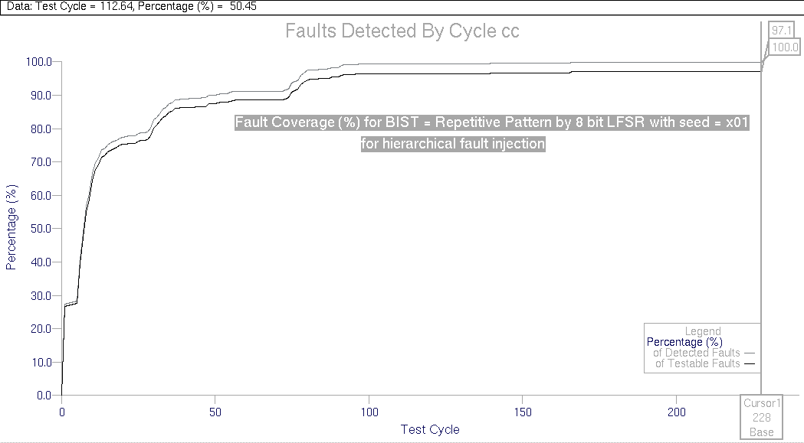
Figure VI-40, Fault coverage (%) for 8 bit LFSR with repetition length, k =4 and seed=x01

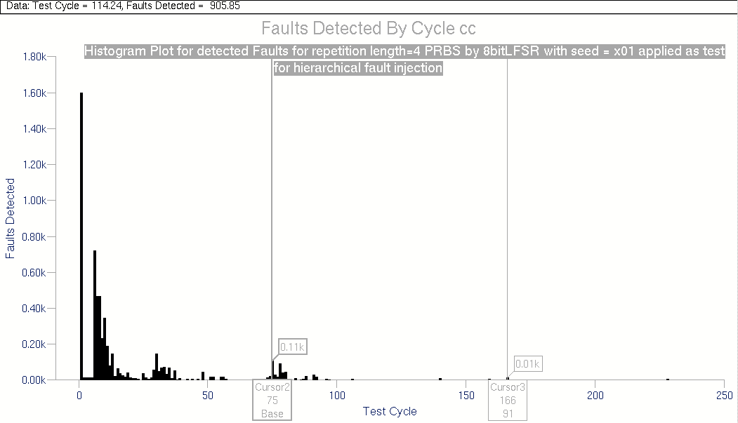
Figure VI-41, Histogram for8 bit LFSR with repetition length, k =4 and seed=x01

Once again from the simulation list, 75th cycle corresponds to 7490ns and 166th cycle corresponds to 16590 ns. The corresponding b&&a values are 77&&BB and BB&&77. Thus, the corresponding seeds are 7B and B7.
•
•
7390.0 FF 66 FF9A
7490.0 77 BB DFED
7590.0 33 DD F907
•
•
16490.0 66 FF FF9A
16590.0 BB 77 DFED
16690.0 DD BB 096F
•
•
Time(ns) ^/b(7:0)
^/a(7:0)
^/product(15:0

Seed = x7B: The simulation results and data for seed = x7B are in:
"CD/MSc/Results/mult8x8/LFSR/LFSR8bit/seed7B/". The fault coverage plot shown in figure VI-42 reveals 97.2% fault coverage in just 154 cycles and 97.1% fault coverage in just 109 cycles.

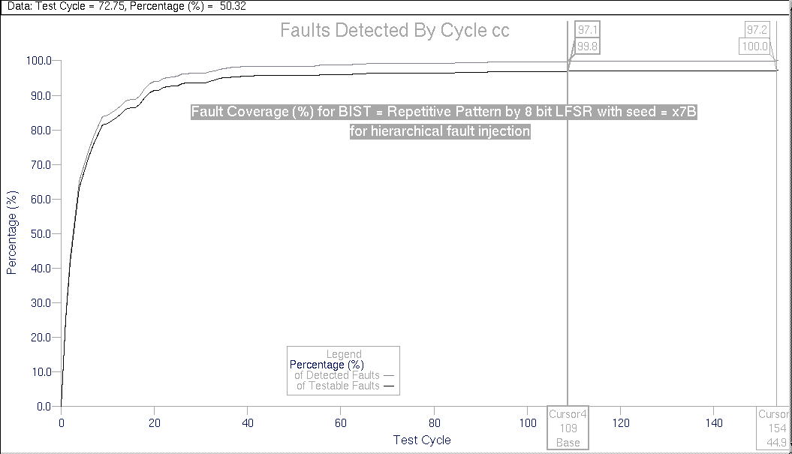
Figure VI-42, Fault coverage (%) for 8 bit LFSR with repetition length, k =4 and seed=x7B

As can be seen in the figure, the fault coverage is almost saturated after around 40 cycles and there is almost no redundancy as there are no flat regions in the ascending part of the curve, which can be verified from the histogram plot in the CD. This test reveals very good test coverage with minimal hardware and test complexity.
Seed = xB7: The simulation results and data for seed = xB7 are in:
"CD/MSc/Results/mult8x8/LFSR/LFSR8bit/seedB7/". The fault coverage plot shown in figure VI-43 reveals an excellent 97.0% fault coverage in just 82 cycles and 97.24% fault coverage in 230 cycles.

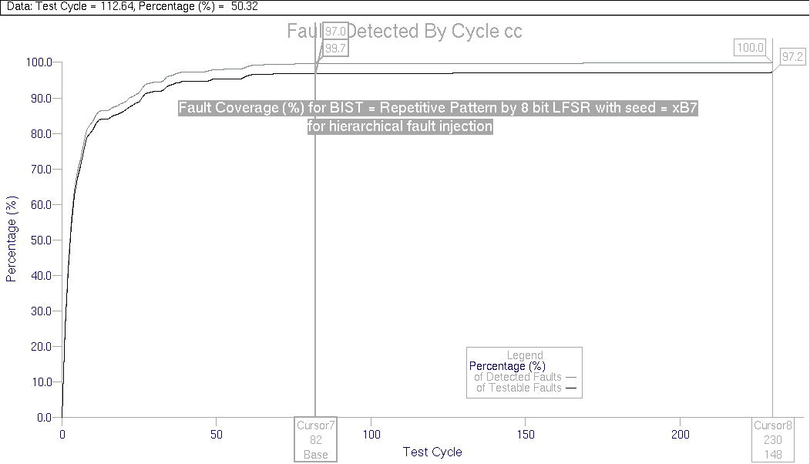
Figure VI-43, Fault coverage (%) for 8 bit LFSR with repetition length, k =4 and seed=xB7

Hence, these two last experiments are extremely efficient and they have comparable if not better results to 16 bit LFSR with seed xEA58 and either of them can be the implementation choice if LFSR is the final BIST decision.

VI.4.6 –BIST = 16 bit CA:
As described in section III, CA are the least known of the two described PRBS generation techniques and have preferable more random characteristics compared to LFSRs despite the higher hardware cost. In this section we scrutinize several CA with different seeds as an alternative to BIST implementation. Once again we generate a Matlab script to produce the stimulus of a hypothetical CA. However, although in the LFSR case the matlab implementation is simply based on modulo 2 summation of tap values and then shifting, the CA computation is a little bit more involved, yet mathematically perfectly described. The schematic model for the matlab implementation is as shown in figure VI-44. The figure displays a CA with 150 cells at 1st and 15th locations, which is an appropriate combination for max-length sequence generation. The details of mathematical computation of CA output is described in section III, pages 10-12, however a slight modification to the matrix manipulations is performed as the Q outputs are represented as a row vector rather than a column vector in matlab. However, the equations hold as the tridiagonal matrix T^{T} = T.

_{Qint(16)}
F-F
16
Q(16)
seed(16)
_{Qint(15)}
Q(15)
Q(9)
_{Qint(14)}
F-F
15
Q(14)
seed(15)
_{Qint(4)}
F-F
4
Q(4)
seed(4)
_{Qint(3)}
F-F
3
Q(3)
seed(3)
_{Qint(2)}
F-F
2
Q(2)
seed(2)
_{Qint(1)}
F-F
1
Q(1)
seed(1)
CK
Q(8)
to B(7:0)
to A(7:0)
0
0
150 cell
90
cell
90
cell
90
cell
150 cell
90
cell

Figure VI-44, Matlab Emulated 16 bit CA circuit

The generated Matlab script is in appendix E-4 and also can be referred from “CD>MSc/DesignFiles/matlab”. The generated output stimuli for different seeds are in "CD/MSc/Results/mult8x8/CA/CA16bit/seedxxxx" directories.

Seed = x0001: Having already become the general initiation point, we once again start with a seed of x0001 for the CA. The simulation data and results are in:
"CD/MSc/Results/mult8x8/CA/CA16bit/seed0001/", the simulation list is saved in binary radix to demonstrate the nonexistent shifting property in CA contrary to the LFSR case. The full exhaustive simulation revealed a 99.12% fault coverage – once again inconsistent with the other full exhaustive cases for an indeterminate reason! – and the fault coverage curve is once again like a step function, very much like desired. However the zoomed fault coverage plot in figure VI-45 reveals the fault coverage reaches 97.2% in 159 cycles, which is worse than all the LFSR cases. The plot shows once again the characteristic property of seed x0001, a flat region right after the start. This plot is very similar to the x0001 case of the LFSR. The histogram shown in figure VI-46 reveals a superior detection at the start as usual however, there is a very strong spread within the first 10K. There are also 2 strong late peaks, one in cycle 34569 and the other in cycle 55870, each detecting 7 faults, which will be our next starting points. Once again referring to the simulation list, the 34569th corresponds to a seed of x8080 and 55870th cycle corresponds to a seed of x534F.

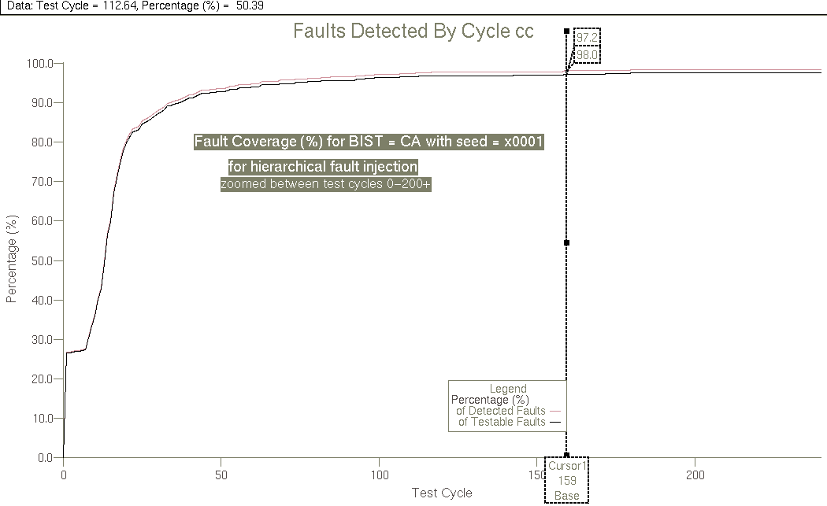
Figure VI-45, Fault coverage (%) for 16 bit CA with seed=x0001

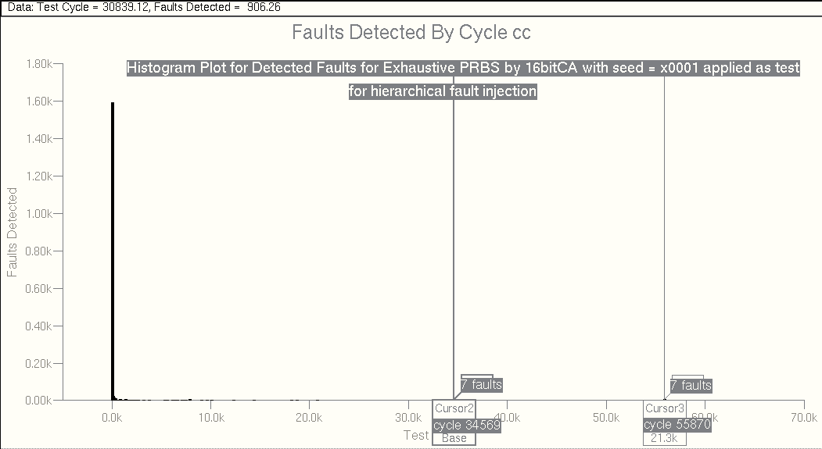
Figure VI-46, Histogram for 16 bit CA with seed=x0001

Seed = x8080: The simulation data and results for this seed are in:
"CD/MSc/Results/mult8x8/CA/CA16bit/seed8080/". Fault coverage curve reveals that 97.2% fault coverage is achieved in 138 cycles, which though very good cannot overperform LFSR. The redundant regions are removed with the seed selection but histogram still shows a strong spread up to 5K. The significant peak at cycle 21302 is exactly the peak that corresponds to the peak at 55870 for seed = x0001.

Seed = x534F: The simulation data and results for this seed are in:
"CD/MSc/Results/mult8x8/CA/CA16bit/seed534F/". The fault coverage shown in figure VI-47 reveals 97.2% fault coverage in just 122 cycles, which is the best achieved result so far. the histogram plot shown in figure VI-48 produces a new peak at cycle 6052 with 6 faults. From simulation list, this corresponds to a seed of D5D5, which is the next candidate for the optimal seed.
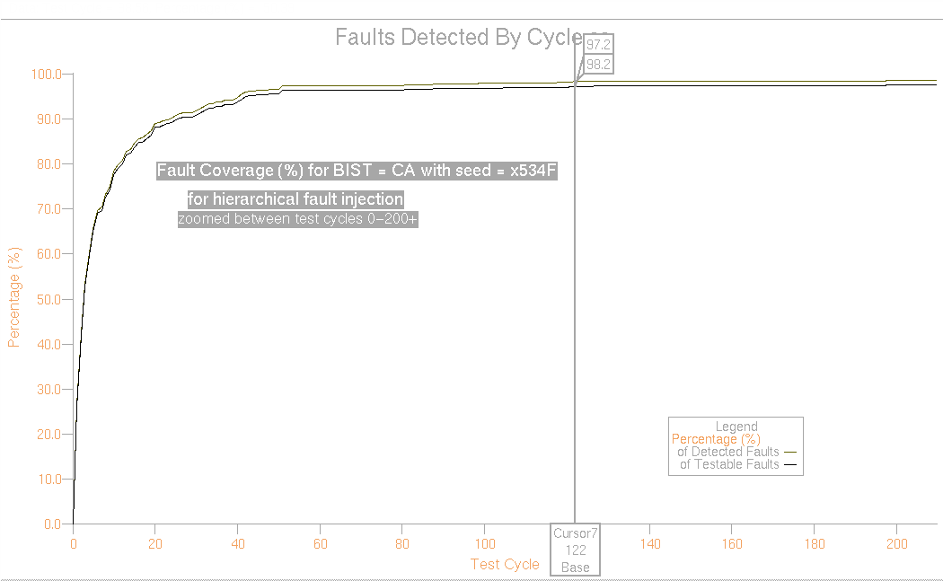
Figure VI-47, Fault coverage (%) for 16 bit CA with seed=x534F

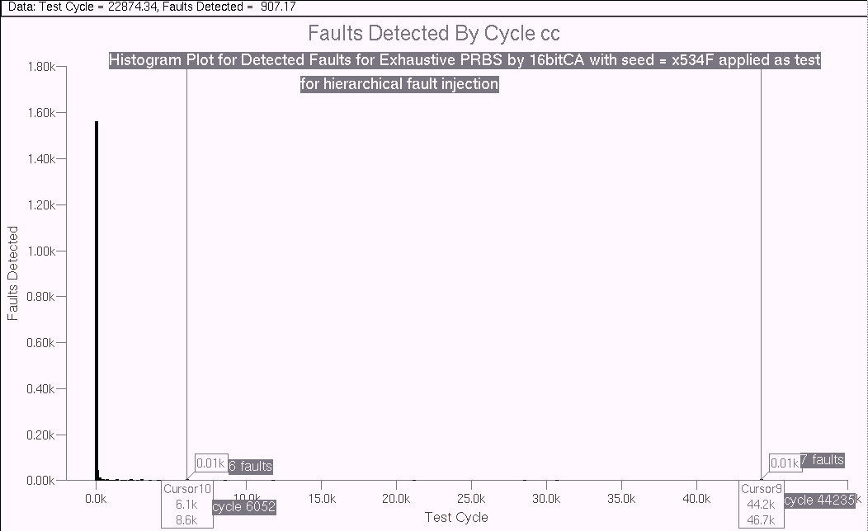
Figure VI-48, Histogram for 16 bit CA with seed=x534F

Seed = xD5D5: The simulation data and results for seed = xD5D5 are in:
"CD/MSc/Results/mult8x8/CA/CA16bit/seedD5D5/", it revealed 97.2% fault coverage in 127 cycles as can be seen from the plots in CD, which is the second best result achieved after 16bit CA with seed x534F.

With these experiments we conclude the investigation of 16 bit CA as BIST, and achieve slightly better results compared to LFSR at some specific cases, however as the general engineering practice the trade-off is in hardware cost. Therefore, there is no single decision that can be made at this point that can state one scheme is "better" than the other one. These relations are based on either performance or cost.

VI.4.7 –BIST = 8 bit CA – Repetitive Pattern:
Similar to the LFSR case, we also investigate the effectiveness of repeated patterns when CA are chosen as the pattern generator circuit. We once again use a repetition length of 4 and consider an 8 bit CA for BIST circuit. We make use of the Matlab script to emulate the outputs of the 8 bit CA with 150 cells located at 2nd and 3rd positions, as shown in appendix E-5 and included in “CD>MSc/DesignFiles/matlab”. The generated output stimuli for different seeds are in "CD/MSc/Results/mult8x8/CA/CA8bit/seedxx" directories.

Similar to figure VI-39, the Q(1:4) outputs are input to both b(3:0) and b(7:4); and Q(5:8) is input to a(3:0) and a(7:4). As usual we start with a seed of x01.

Seed = x01: The simulation data and results are in:
"CD/MSc/Results/mult8x8/CA/CA8bit/seed01/". As can be seen from the fault coverage plot, it achieves 97.1% fault coverage in 139 cycles and 97.2% fault coverage in 179 cycles. The results are not better than the LFSR with seed x7B, but as the initial starting point, it gives sufficient information for seed determination. The histogram, shown in figure VI-49 is quite spread and there are several redundant regions. Moreover, the spread consists of few bursts at various locations. Some of the significant cycles are, cycle 50 with 41 detected faults, cycle 60 with 64 detected faults, cycle 138 with 7 faults and cycle 180 with 9 faults. There is a very spread burst between cycles 60-100, starting at 57th cycle. Therefore, one of the good starting points might be 57th cycle as it will cover up to 100 burst at the hyperactive startup phase. In the same fashion, starting from cycle 138 will also cover the cycle 180 peak. As can be deduced, we do not take any precaution for cycle 50, under the hope that, starting later than 50 might have the chance to cover the faults detected by 50 with another vector, thus reducing any adverse effect leaving 50 uncovered might cause. Nevertheless, our expectation is, if cycle 50 pattern cannot be compensated with the new start points, we'll observe a peak at
255 + 50 – 57 + 1 =249th cycle for 57th cycle as start point
and
305-138 + 1 = 168th cycle for 138th cycle as start point

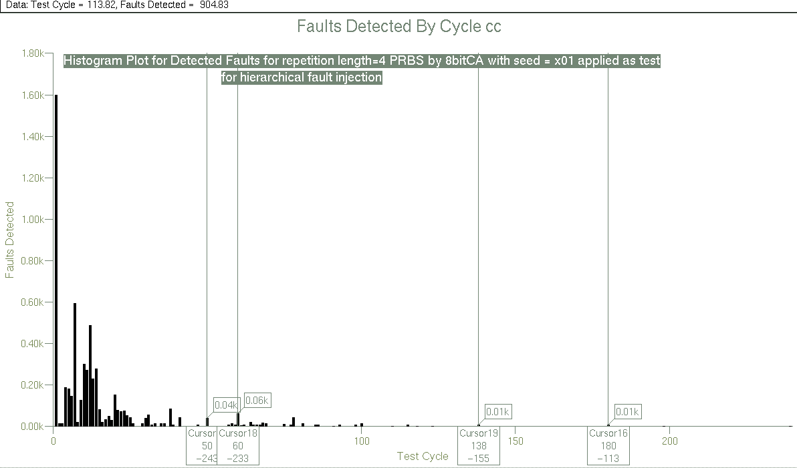
Figure VI-49, Histogram for 8 bit CA with seed=x01

Once again, referring to the simulation list file, the seed corresponding tom57th cycle is: x6D and to 138th cycle is: xAB.

Seed = x6D: The simulation data and results for seed = x6D is in:
"CD/MSc/Results/mult8x8/CA/CA8bit/seed6D/". The fault coverage plot in figure VI-50 shows it achieves 97.2% fault coverage in just 124 cycles, while reaches 97.0% in 123 cycles. It can be verified that the 124 cycles result is the best achieved so far, however, seed=x7B exceeds 97.0% before 109th cycle. Therefore, we face the controversy once again, that different BIST strategies perform better for different target fault coverages. 

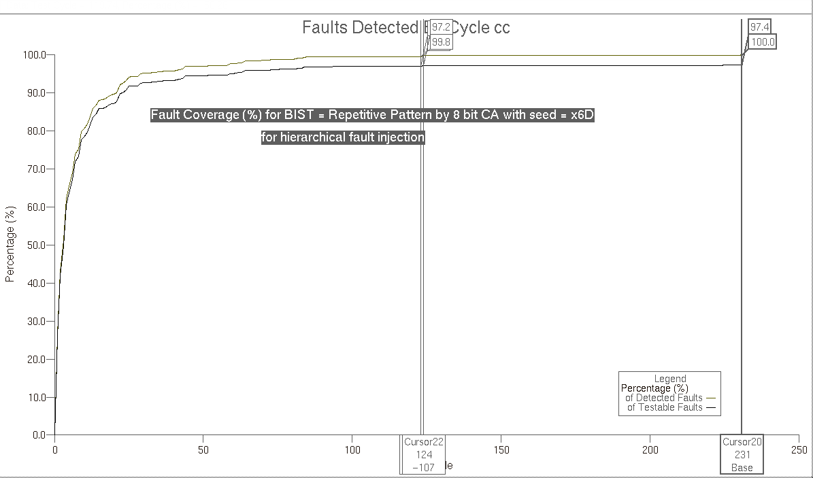
Figure VI-50, Fault coverage (%) for 8 bit CA with seed=x6D

The histogram plot that can be accessed from the CD shows a very high detection efficiency, with the highest peak at 124th cycle – where the fault coverage jumps from 97.0% to 97.2% -, which was to be expected as the highest late we had considered in previous seed=x01 case was at 180th cycle. To verify this, 57+124-1 = 180, shows the 180th peak is the 124th peak of this simulation.

Seed = xAB: The simulation data and results for seed = xAB is in:
"CD/MSc/Results/mult8x8/CA/CA8bit/seedAB/". As can be verified from the fault coverage plot in figure VI-51, the fault coverage reaches 97.19% in 125 cycles and 97.1% in just 110 cycles.
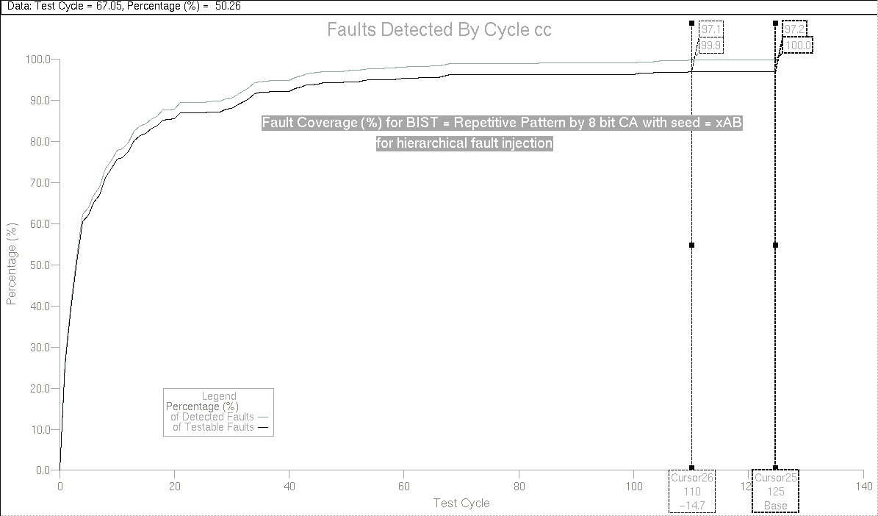
Figure VI-51, Fault coverage (%) for 8 bit CA with seed=xAB

This concludes our investigation of different BIST techniques and in the next subsection, we discuss the results of these techniques.

VI.4.8 – Summary of BIST Techniques:
As a brief sum up, it is observed that, LFSR and CA pseudorandom techniques perform better than deterministic techniques, due to their almost random nature of pattern sequence. The fault coverage builds up much quickly. In regard of this opinion, it is expected that CA perform better than LFSR as they are free from the shifting behavior of LFSRs, however, very slight improvements if any are observed with application of CA and therefore it is not very feasible to incur the additional hardware cost of CA for this insignificant improvement. On the contrary, the application of repetitive patterns is seen to provide excellent fault coverage with only a small set test vectors. As thoroughly scrutinized, the 16bit full exhaustive patterns are not significantly better than 8 bit repetitive patterns for both LFSRs and CA with the test length significantly reduced.

Yet, it is not very obvious which BIST scheme is more appropriate for implementation. To have an overall view of the results, we repeat the outcomes of each section in here in table 20. Although there is no such measure that can be induced to state one method is 'better' than the others, one of the evident observations is, repetitive patterns with only 8 bit pattern generators are almost equally efficient as 16 bit pattern generators. Therefore, the BIST choice can safely be an 8 bit pattern generator. Among the 8 bit generators, upcounter is out of scope and the choice is between CA and LFSRs. The BIST implementation can be either LFSRs with seeds x7B or xB7, or CA with seeds x6D and xAB. However, due to the additional hardware cost of CA, the probable choice will be between the two LFSRs.

BIST method | Fault Coverage vs. # of patterns
8 bit Upcounter Using Repetitive patterns with k=4 | 97.02% with 228 patterns
16 bit LFSR with seed=x0001 | 97.2% with 157 patterns
16 bit LFSR with seed=xEA58 | 97.2% with 134 patterns
16 bit LFSR with seed = x8080 | 97.2% with 153 patterns
8 bit LFSR using repetitive patterns with k =4 and seed=x01 | 97.12% with 228 patterns
8 bit LFSR using repetitive patterns with k =4 and seed=x7B | 97.2% with 154 patterns  97.1% with 109 patterns
8 bit LFSR using repetitive patterns with k =4 and seed=xB7 | 97.0% with 82 patterns  97.24% with 230 patterns
16 bit CA with seed=x0001 | 97.2% with 159 patterns
16 bit CA with seed=x8080 | 97.2% with 138 patterns
16 bit CA with seed=x534F | 97.2% with 122 patterns
16 bit CA with seed=xD5D5 | 97.2% with 127 patterns
8 bit CA using repetitive patterns with k =4 and seed = x01 | 97.1% with 139 patterns  97.2% with 179 patterns
8 bit CA using repetitive patterns with k =4 and seed = x6D | 97.2% with 124 patterns  97.0% with 123 patterns
8 bit CA using repetitive patterns with k =4 and seed = xAB | 97.19% with 125 patterns  97.1% with 110 patterns
Table 20, Summary of BIST Results

Before implementing the BIST generator, being very cautious, we first decide to implement the output data compressor, with the initial and hopefully last choice of a signature analyzer in order to make sure the data compression stage does not change the effectiveness relation between the investigated pattern generation schemes.

VI.5 – MISR Implementation for BIST

Having finalized the investigation for pattern generation, we move to output data compression. Signature analysis is the generally applied technique in data compression and has been our first choice of implementation. The regular multiplier structure suggests that it is not probable to have a single stuck at fault that causes two distant separate multiplier outputs change at the same time and therefore we expect a very low fault masking probability with signature analyzer. The signature analyzer is designed as described in design entry section and synthesized into eddm-schematic. The synthesized 16 bit signature analyzer is in:
" CD/MSc/DesignFiles/Renoir/Eddm_sch/signalyzer_16_10110111101100011/"
The generated schematic for signature analyzer is shown in figure VI-52 and can be accessed from "CD/MSc/Results/Sign16/Sign16sch.gif".
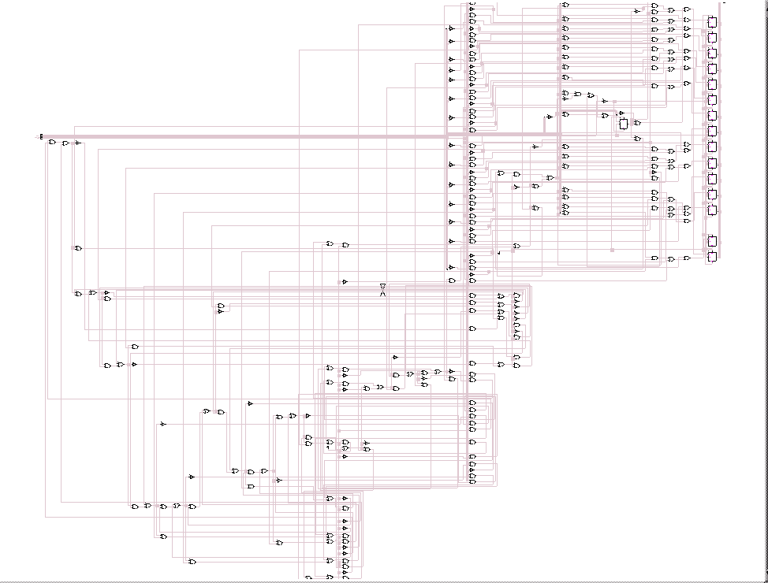
Figure VI-52, Generated schematic for 16 bit signature analyzer

As described in design entry section, the signature analyzer is assured for correct functionality in VHDL level, then it is combined with the multiplier circuit at one higher level into MultSign8x8, which is then synthesized into eddm-schematic as in:
"CD/MSc/DesignFiles/Renoir/Eddm_sch/multsignnxn_10110111101100011_8/"
The schematic for MultSign8x8 is as shown in figure VI-53 and in:
"CD/MSc/Results/MultSign8x8/multsignsch.gif".

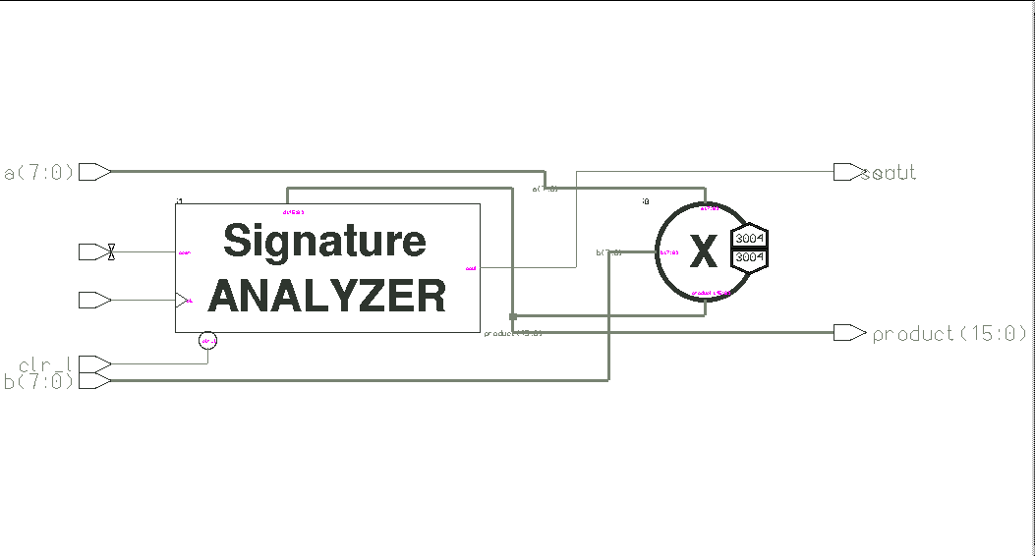
Figure VI-53, Generated schematic for 16 bit signature analyzer + 8x8 multiplier
Now, in order to observe how much fault masking occurs with signature analysis, we used the stimulus for 8 bit LFSR with seed=x7B to drive the multiplier. We have also included 3 signature analyzer signals as shown in figure VI-54.
clr_L
CK
50 ns
100 ns
Scan

Figure VI-54, Signature analyzer input signals

As also shown in figure VI-53, we used the same fault dictionary to generate the same faults in the multiplier only to be able to make a comparison between the two cases. Clearly, we only strobed the single bit signature analyzer output, 'sout' to detect any faulty output. As a result of the fault simulation, 96.80% fault coverage is achieved by observing only the signature analyzer output, which is very slightly lower than the result we achieved by observing all 16 multiplier outputs. All the simulation data and results are in:
"CD/MSc/Results/MultSign8x8/", and they are not included in the report for brevity. However, we show the histogram in figure VI-55, as it bears an important information about the minimal effective test set.

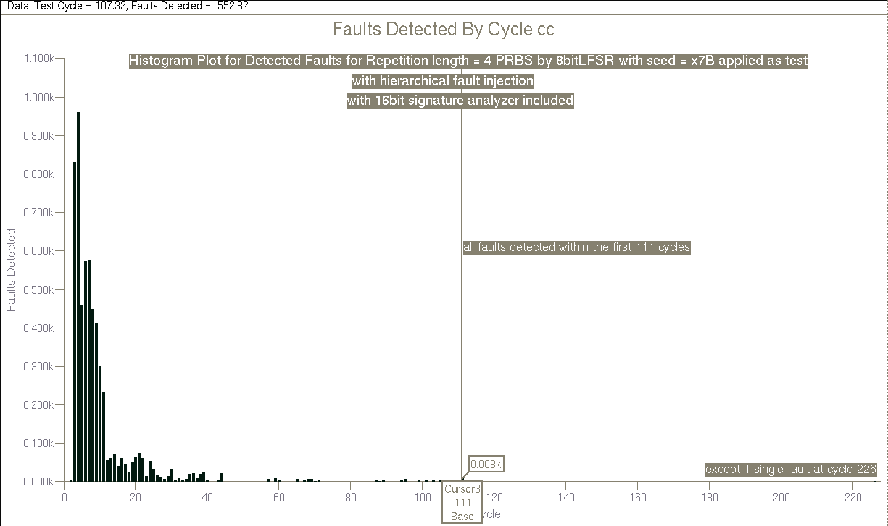
Figure VI-55, Histogram for MultSign8x8, with 8 bit LFSR with seed=x7B as input
As seen in the histogram, all the faults are detected in the first 111 cycles, except for only 1 at cycle 226, which has a contribution: 1/6008 = 1.66*10⁻⁴ to the total fault coverage. Therefore we can achieve the same fault coverage with only 111 patterns.

This immediately concluded our output compression investigation due to the excellent results, moreover the above outcome also suggested we use seed=x7B LFSR as the pattern generation implementation of choice.

VI.6 –LFSR Implementation for BIST

As the last and most elaborated portion of the BIST circuitry, we designed the LFSR as described in the design entry section. We then synthesized the parameterized LFSR into an 8 bit LFSR with seed x7B and taps at 1,5,6 and 8, which corresponds to the LFSR shown in figure VI-39. The synthesized LFSR is in:
"CD/MSc/DesignFiles/Renoir/Eddm_sch/lfsr_8_01111011_10001101/"

The generated schematic for the LFSR is shown in figure VI-56 and can be accessed from " CD/MSc/Results/LFSR8/LFSR8sch.gif".
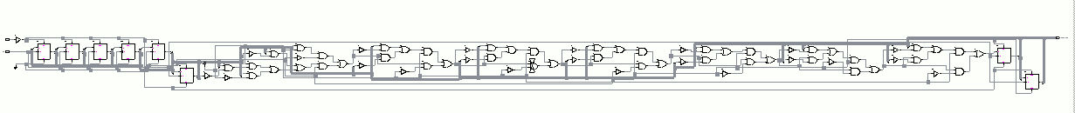
Figure VI-56, Generated 8 bit LFSR

Finally, we connect all the 3 parts of the BIST + multiplier circuit to achieve the final multiplier circuit with included input pattern generation and output compression. The Renoir design can be referred from appendix B-4, which is the implementation of blocks as described in repetitive pattern LFSR pattern generation and output compression phases. The final synthesized design is in: "CD/MSc/DesignFiles/Renoir/Eddm_sch/lfsrmultsignnxn_ 10110111101100011_8_10001101_01111011_8/

The top-level schematic for the complete design is shown in figure VI-57 and can be accessed from: " CD/MSc/Results/LFSRMultSign8x8/LFSRMultSignsch.gif"

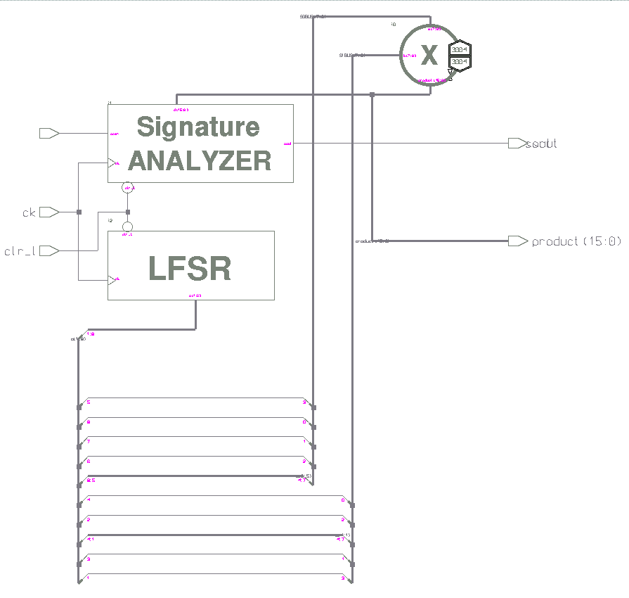
Figure VI-57, Generated schematic for complete design for mult8x8

In order to assure our software based observations match with the hardware implementation, we perform fault simulation for the final circuit by applying only the clk, clr and scan signals as the stimuli, as in figure VI-54. We only strobe the sout output of the signature analyzer and with the 6008 faults injected into the multiplier as shown in figure VI-57, we achieve a 97.07% fault coverage as shown in figure VI-58. Once again, the results are not exactly the same as the 2 previous simulations performed under the same scheme. In order to alleviate any suspicion about any flow in the experiment, we wrote a small UNIX script that takes the two simulation list files and compares the input output fields for the files, which is in "CD/MSc/Results/convcomp". The resultant compare as shown in: "CD/MSc/Results/compresult" reveals, the simulation stimuli are exactly the same throughout the simulation, therefore, the slight difference in fault coverage measurements is attributed to the CAD tool again.

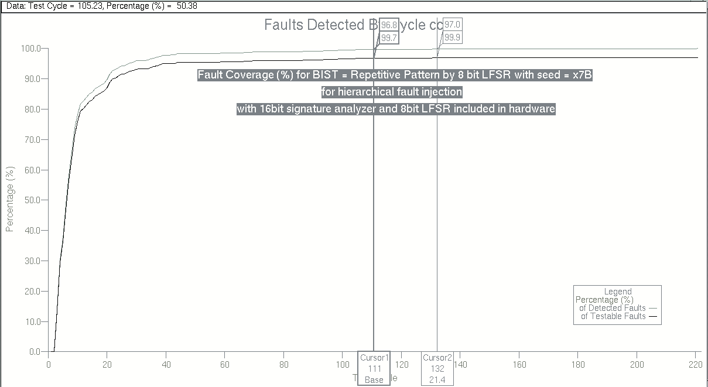
Figure VI-58, Fault coverage (%) for LFSRmultSign8x8

As one last step to the investigation, we include the BIST circuitry in the fault simulation and inject hierarchical faults to the LFSR and the signature analyzer, however, as the D-flip-flop primitives in QuickFault have one inverted output as well as the noninverted ones, we have several untestable pins in the design, which must be nofaulted. Moreover, the set and reset pins of the flip-flops are also problematic one for each flip-flop is hardwired or dangling. Nevertheless, the fault injection increases total fault count to 8016, with 6008 faults in multiplier, 448 in LFSR and 1560 in signature analyzer. The final fault grade, which is in:
"CD/MSc/Results/LFSRMultSign8x8/allfaulted/faultsummary.txt" reveals 96.95% fault coverage, which is very close to the only multiplier case.

This finally concludes the whole BIST investigation, we observe very satisfactory results with LFSR as pattern generator and signature analyzer as output data compressor. As the next step in the project – which is now more of curiosity due to the repetitive patterns – we deploy larger multipliers and perform fault simulation with the same amount of input test vectors, using repetitive patterns with a repetition length of 4.

VI.7 –16x16 Multiplier with BIST

We move from the 8x8 multiplier to 16 by 16 multiplier as the new circuit to be tested with repetitive patterns. As with the circuit size, we expect the gate count to quadruple and thus we expect to have 4 times as much faults on the circuit as the 8x8 multiplier. The synthesized LFSRmultSign16x16 is in
"CD/MSc/DesignFiles/Renoir/Eddm_sch/lfsrmultsignnxn_16_100010100010101010001010000000101_16_10001101/" and the new generated schematics for 16x16 multiplier, 32 bit signature analyzer and top level circuit are shown in figures VI-59 to VI-61, which can be also accessed from "CD/MSc/Results/LFSRMultSign16x16/"
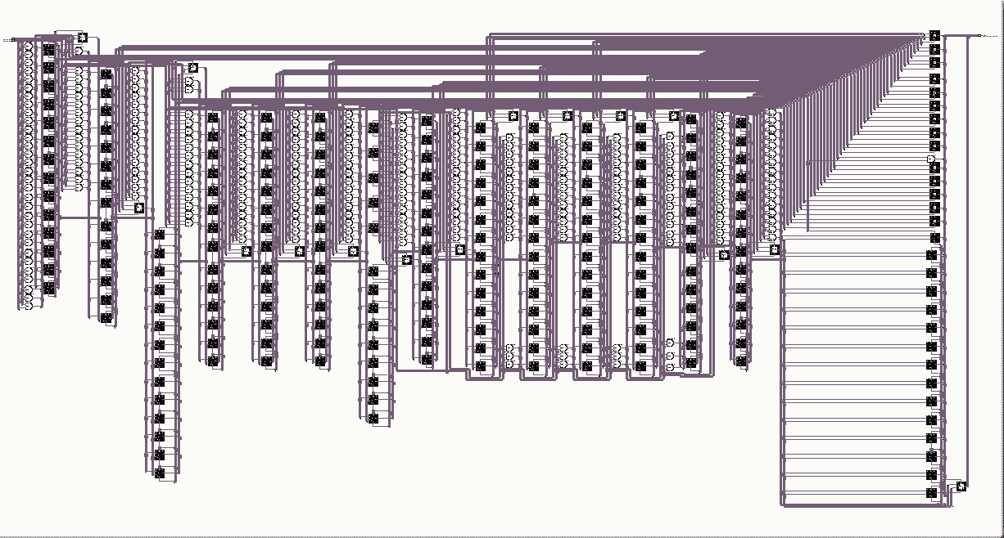
Figure VI-59, Generated 16x16 schematic
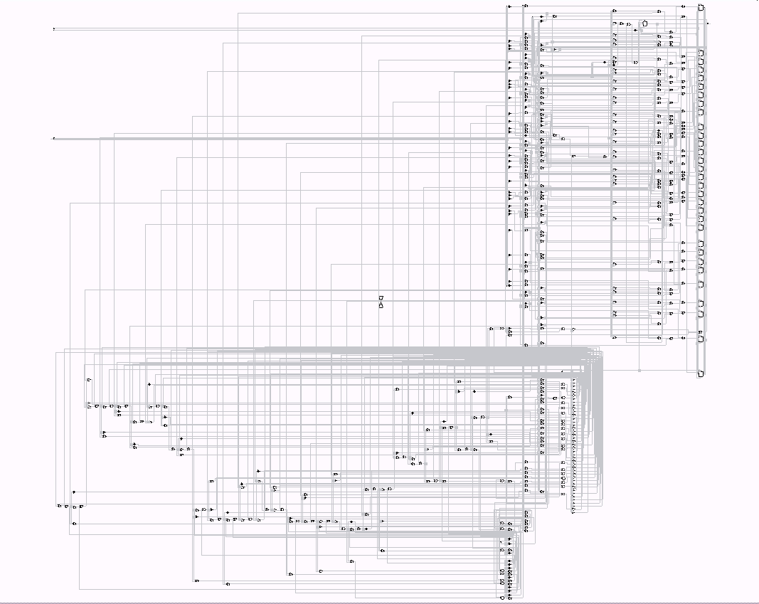
Figure VI-60, Generated 32 bit signature analyzer
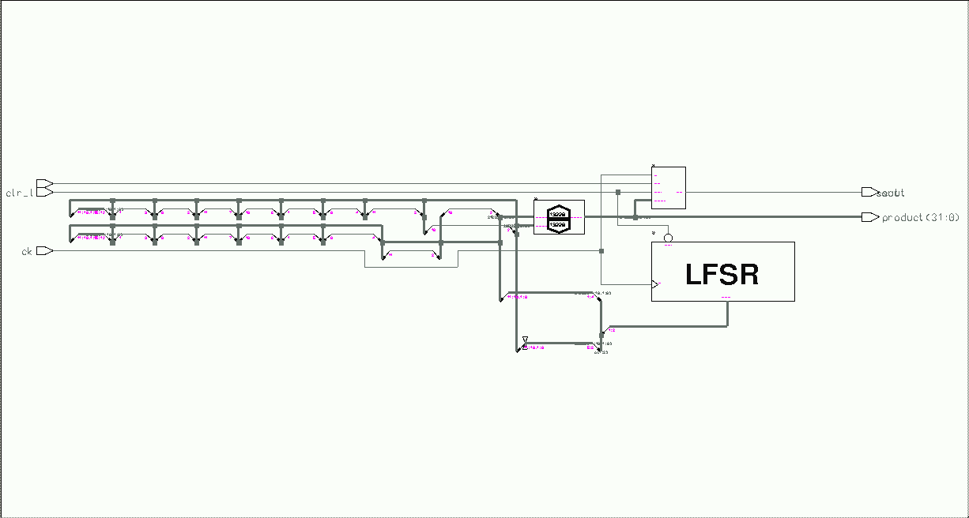
Figure VI-61, Top level circuit

Here we observe the advantage of making separate symbols for each block, as the component counts increase, this turns out to be only feasible way to distinguish between blocks in the schematic. Hence there is no new schematic for the LFSR as we still use a single 8 bit LFSR for repetition length 4 patterns.

The simulation data and the results for the fault simulation of 16bit top level circuit are in
"CD/MSc/Results/LFSRMultSign16x16/" and as seen in the grade and fault list, the total number of faults exploded up to 26456, which is almost 4 times the 8x8 multiplier faults.

We perform fault simulation, the same way we have done for 8x8 multiplier, with repetitive PRBS with k=4, and obviously now all the 4 bit b inputs b(15:12), b(11:8) , b(7:4) , b(3:0) are connected to LFSR output (1:4) and all the 4 bit a inputs a(15:12), a(11:8) , a(7:4) , a(3:0) are connected to LFSR output (5:8). As shown in figure VI-62, we achieve an unexpectedly good result. The fault coverage reaches 97% in just 57 cycles and it climbs up to 98.83% in the whole test. This extremely satisfactory result reveals an excellent conclusion, the repetitive patterns provide very high fault coverage with a fixed number of patterns independent of the size of the multiplier. 
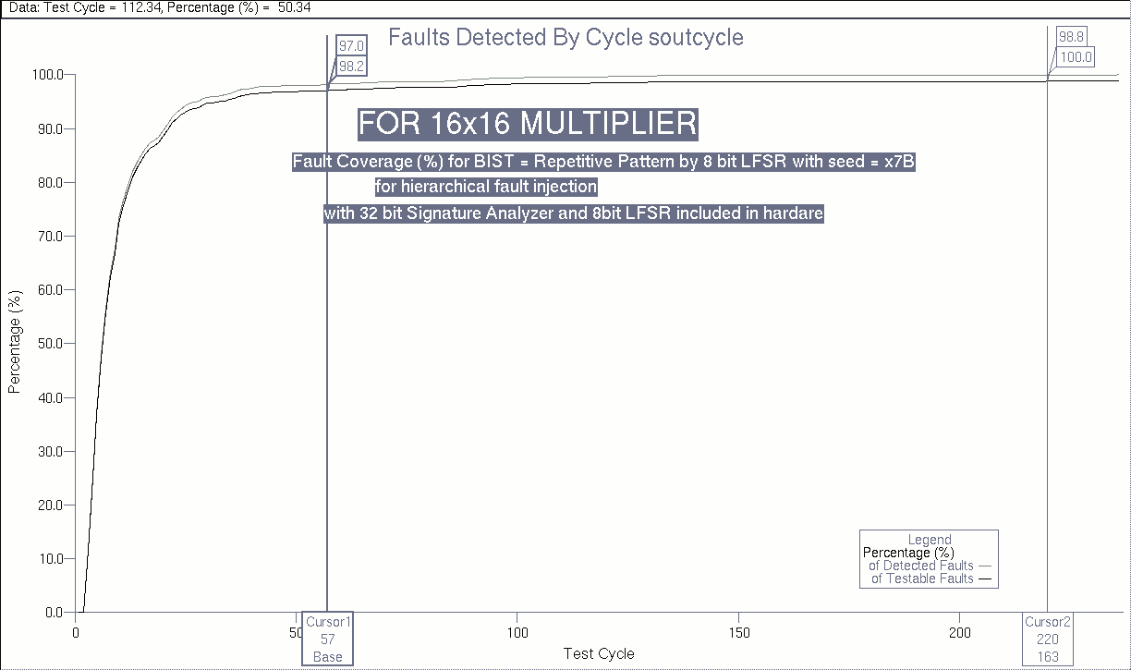
Figure VI-62, Fault coverage (%) for LFSRmultSign16x16

Despite it looks counterintuitive, the fault coverage even improved as we increased multiplier size, when compared to figure VI-58 of 8x8 multiplier.

VI.8 –Larger Multipliers with BIST

To verify our observations we increase the circuit size to a 32x32 multiplier, still with the 8 bit single LFSR for input test generation. The synthesized circuit is in:
"CD/MSc/DesignFiles/Renoir/Eddm_sch/lfsrmultsignnxn_32_100000001000100000001000100010001000000010001/". Once again the faults are expected to quadruple over 16x16 multiplier and as can be verified from "CD/MSc/Results/LFSRMultSign32x32/", the total fault count increased to 111128.

The new generated schematics for 32x32 multiplier, 64 bit signature analyzer and top level circuit are shown in figures VI-63 to VI-65.

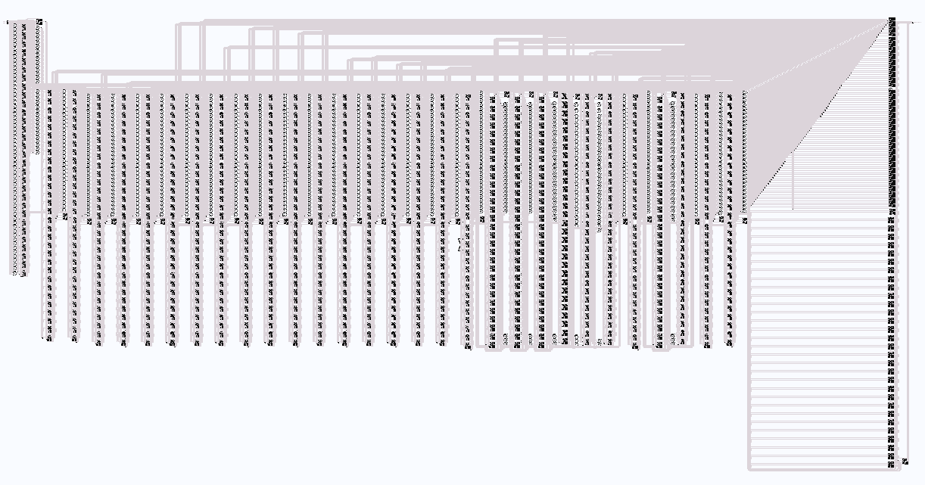
Figure VI-63, Generated 32x32 multiplier schematic

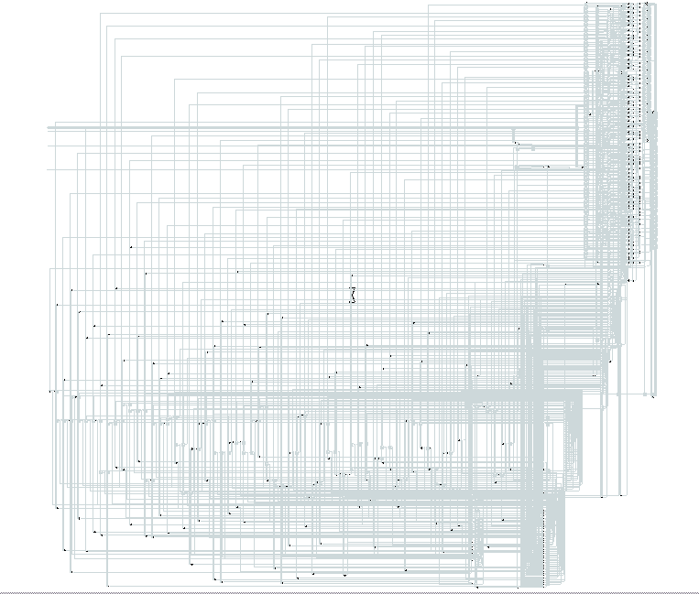
Figure VI-64, Generated 64 bit signature analyzer
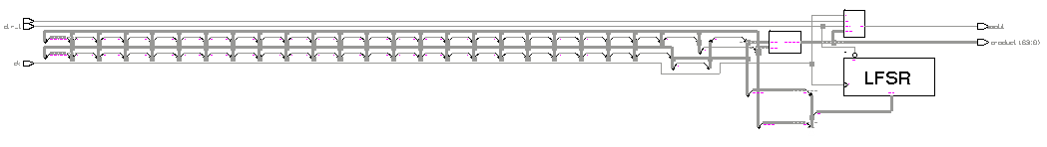
Figure VI-65, Top level circuit schematic for 32 bit multiplier

Unfortunately, with this much faults, the fault simulation could not complete and crashed due to insufficient memory. The post synthesis simulation results could be obtained, and can be referred from CD for concordance, but no fault simulation data except for fault list is available.

We have also designed a 24x24 multiplier and synthesized into eddm-schematic, but the fault simulation could only continue for 112ns, which is it crashed while evaluating the 2nd input pattern. Therefore, we ere unable to achieve any results beyond 16x16 multiplier.

Thus, we conclude our investigation for BIST and reach the conclusions repeated a few times within the text. PRBS techniques, in combination with repetitive patterns are seen to be unbelievably efficient in fault detection, regardless of the size of the multiplier. Signature analyzer, reduces the output data volume to a single bit, yet incurs insignificant loss in fault detection. CA, though the more random output nature promises significant enhancements, is not seen to be worth sacrificing the additional hardware cost for the very slight to no improvement in fault detection.

Recalling the initial argument, the astute reader will notice this is not completely true for the HLandH gates, and this will constitute the context of next section. However, to present the development of concepts, the two are described separately.
Hence this is 97.2% rather than 97.02% of previous test, so even smaller cycles can achieve 97.02%

