V- Multiplier and BIST Circuit Design

As described in the introduction, in this section we describe the design of a parameterized, signed, parallel multiplier, using VHDL via Renoir. We describe signed binary multiplication and briefly discuss various multiplier architectures and then expatiate upon the design of a parameterized CPA multiplier. Chronologically, the mentioned steps are the first in design progress. Then, we explain the design of the signature analyzer used in the design and finally the LFSR design, which are however, chronologically after the BIST investigation phase during design progress.

V.1 – Multiplier Architecture

In general, the multiplier function is divided into two major parts: 1) Bit product generation 2) Addition of bit products to form the final product. Different multiplier architectures emerge from how these two steps are performed. In unsigned multiplication, the second step is mere addition, while in signed multiplication, the second step includes an addition or subtraction in the final level of partial product accumulation depending on the most significant bit (MSB) of multiplier. In unsigned multiplication, final product for an NxN multiplication is 2N bits. However, for signed multiplication, 2N-1 bits are sufficient as long as both multiplier and multiplicand do not take their most negative value simultaneously. Two distinct properties of signed multiplication are: 1) Multiplier and multiplicand are not completely symmetric in hardware architecture 2) In order to keep track of sign, sign extension must be handled during partial product additions.

V.1.1 – Twos Complement Multiplication:
Twos complement multiplication is conceptually not different from mundane multiplication, in terms of binary domain, the only difference is, instead of the ‘-’ sign, the MSB holds the information about the number being positive of negative – therefore contrary to unsigned numbers, adding 0s to left might have a significance –. As in decimal domain, multiplicand (MD) is multiplied by the ‘value’ of each bit of multiplier (MR), and as in decimal, the values of higher significant bits of multiplier are assessed by a left shifting operation performed during partial product addition. As the value of MSB in multiplier, named Sign Bit (SB), can be either negative or zero in twos complement arithmetic, the final step is either a subtraction or 0 addition. In general twos complement multiplication can be demonstrated as in Figure V-1:

SB₁  MD  MR | x | y | z

SB₂ | a | b | c

SB₃  c . MD (SB₃ = c.SB₁) | SB₃ | SB₃ | SB₃ | SB₃ | c.x | c.y | c.z

SB₄  b . MD (SB₄ = b.SB₁) | SB₄  b . MD (SB₄ = b.SB₁) | SB₄  b . MD (SB₄ = b.SB₁) | SB₄  b . MD (SB₄ = b.SB₁) | b.x | b.y | b.z

SB₅  a . MD (SB₅ = a.SB₁) | SB₅  a . MD (SB₄ = a.SB₁) | SB₅  a . MD (SB₄ = a.SB₁) | a.x | a.y | a.z
(-SB₂) . MD
[SB₆ = SB₂.(SB₁)’]
SB₆ | SB₆ | x* | y* | z*

Final Product
SB_{p} | P₆ | P₅ | P₄ | P₃ | P₂ | P₁ | P₀

Figure V-1, twos complement multiplication

In the above demonstration, the shaded bits are extended signs for correct signed addition. (.)’ denotes the complement of the binary value. As can be deduced, the last set of partial products is either all 0s if SB₂ is 0, or twos complement negation of multiplicand if SB₂ is 1; which is stated as “(-SB₂) . MD”. Hence, in the above description, it is described such that, for an NxN multiplication, each partial product row must be sign extended to 2N bits, which is to emphasize the correct operation if all the rows are added simultaneously. However if we consider adding first 2 rows at once and then adding the result to the consecutive rows one by one with a cumulative fashion, the sign extension scheme can be adjusted as described in figure V-2. Hence, except for the first row, all rows now require only one bit sign extension, which in turn reduces the required number of bitwise additions by (N-1)! –(N-1).

As observed, unlike unsigned multiplication, the partial summations require N+1 bitwise additions for each accumulation step. In unsigned addition, the MSB of sum is gathered from the carry out output of the MSB adder however, in signed multiplication, the adder terms are sign extended and the MSB is the final adder’s sum output, where the carry out is discarded.

SB₃ | SB₃ | SB₃ | c.x | c.y | c.z

SB₄ | SB₄ | b.x | b.y | b.z

SB | SB | . |  | . | .

SB₅ | SB₅ | a.x | a.y | a.z

SB | SB | . |  | . | .

SB₆ | SB₆ | x* | y* | z*

SB_{p} | P₆ | P₅ | P₄ | P₃ | P₂ | P₁ | P₀

Figure V-2, sign extension after ordering summation

However, as described in [8], a slight modification in the MSB adder can alleviate this redundancy. Regarding the above scheme, signed addition of two N bit numbers can be demonstrated as in figure V-3:
C₀
FA
1
B₀
A₀
C₁
S₀
FA
2
B₁
A₁
C₂
S₁
FA
N-1
B_{N-2}
A_{N-2}
C_{N-1}
S_{N-2}
C_{N-2}
FA
N
B_{N-1}
A_{N-1}
C_{N}
S_{N-1}
0
FA
N+1
B_{N-1}
A_{N-1}
C_{N+1}
S_{N}

Figure V-3, sign extended addition of signed numbers

The shaded sign extensions for A and B inputs produce the MSB of the sum. When we consider the logical functions of sum and carry out circuits, the sum logic is true when either one or all 3 of the inputs are true and carry out logic is true when at least 2 of the inputs are true. These can be expressed in Boolean domain as:

Sum = A(B)’(C_{in})’ + (A)’B(C_{in})’ + (A)’(B)’C_{in} + ABC_{in} = A ⊕ B ⊕ C_{in} (21)
And
Cout = AB + AC_{in} + BC_{in} (22)

Now describing C_{N} in figure V-3, in terms of the above Cout function:
C_{N} = A_{N-1}B_{N-1} + A_{N-1}C_{N-1} + B_{N-1} C_{N-1} (23)
and expressing S_{N} in terms of above Sum function:
S_{N} = A_{N-1} ⊕ B_{N-1} ⊕ C_{N} (24)
We then substitute the C_{N} expression in S_{N} expression, which reveals:
S_{N} = A_{N-1} ⊕ B_{N-1} ⊕ (A_{N-1}B_{N-1} + A_{N-1}C_{N-1} + B_{N-1} C_{N-1})
and upon simplification of this expression we reach:
S_{N} = A_{N-1}B_{N-1} + A_{N-1}(C_{N-1})’ + B_{N-1}(C_{N-1})’ (25)

Hence, this expression is almost the same as the carry out function for N^{th} adder, with just the carry in inverted. The revelation of this expression is, if we modify the carry out of the N^{th} adder as above, we might then use that carry out as the S_{N} bit, without the expenditure of the N+1th adder. Calling this adder with modified carry out, MSB Full Adder (FA), the adder circuit described in figure V-4 then turns out to be almost at equivalent cost to an unsigned adder circuit.
C₀
FA
1
B₀
A₀
C₁
S₀
FA
2
B₁
A₁
C₂
S₁
FA
N-1
B_{N-2}
A_{N-2}
C_{N-1}
S_{N-2}
C_{N-2}
MSB
FA
N
B_{N-1}
A_{N-1}
S_{N}
S_{N-1}
0
S_{N}

Figure V-4, Modified signed adder

With this modification, each partial sum in multiplication is reduced to N bitwise additions rather than N+1 case described in figure V-2. However, we should be aware that, sign extension requirement is not fully overcome with this method, as for two unequal length operands, the shorter one must still be sign extended up to the length of the longer one.

V.1.2 – Multiplier Architectures:
As discussed at the beginning of the section, different multiplier structures emerge from how the bit product generation and partial summations are performed. Each of the to be described structures have their own advantages and shortcomings compromising speed, power, hardware cost and regularity in structure. Although in general signed multiplication is described as a sign extended unsigned multiplication in most of the cited references, some of these can be modified to the above described scheme.

Of the most well known architecture, CPA multiplier ripples the carries through each row of additions and thus, it actually performs exactly the operation described in figure V-2. the general hardware structure of a CPA multiplier is a matrix of adders with each row rippling the carries to the MSB, which is the modified MSB FA. The structure of an unsigned CPA multiplier is described in [3, p.938], [7, pp. 95 – 98] and [9, pp. 2 – 6]. Structures for signed CPA multiplier are described in [9, p.16], using a regular sign extension scheme and in [8, pp. 39 – 40], which utilizes the modified MSB FA.

CSA multiplier, which has the exact same hardware construct with CPA multiplier for unsigned multiplication, makes use of the fact that, the internal summation results are not required for the output, and instead of rippling the carries through each row, it transfers individual carries to the following row. In carry save structures, a final stage for adding the sums and carries is required, which is named, vector merging addition. CSA multipliers whose final stage is performed with carry ripple addition are named “Braun Array Multipliers”([7]). The architectures for unsigned CSA multipliers are described in [3, p. 938], [6, pp. 344 – 348], [7, pp. 99 – 101] and [9, pp. 10 –11]. One significant advantage of CSA multiplier is, the critical path is single, contrary to 2 critical paths in CPA multiplier ([9, pp. 9 – 10]. Moreover, in the general structure, CPA multiplier requires 3(N-1) adder delays – see MVSD1 ILP, Q.3 for derivation –, [6, p.344] asserts CSA multiplier requires 2N+1 adder delays, for all the outputs to stabilize. Signed CSA architectures are described in [9, p.17], which uses the regular sign extension scheme and in [4], which also uses sign extension and a modified adder array without a final vector merging adder.

Tree or Wallace tree multipliers are a further modification of CSA multipliers, which compromise a regular structure for performance improvements. In Wallace tree multipliers, all partial products are first computed in parallel and then they are added in an adder tree in concordance with the carry save addition principles. A final vector merging adder is again required to combine the final carry and sum vectors. Unsigned tree structures are described in [3, p.939], [7, pp.103 – 105] and [10, pp. 160 – 165]. A signed Wallace tree architecture is described in [22, pp. 77 – 80], which applies a specific algorithm for twos complement multiplication.

Modified Booth’s Array Multiplier, which is the most commonly used multiplier in datapath structures as all but most synthesizers generate Modified Booth’s Multipliers during synthesis ([2]), recodes the multiplier in 2 bits at a time. Thus, unlike to the previously described multipliers, Booth multiplier modifies the partial product generation structure and reduces the number of generated partial products. The algorithm takes 2 bits of the multiplier at a time and adds 0/±1/±2 . multiplicand, according to the recoding, which also considers the previous bit of multiplier. Recoding is done for 2 bits only in practice, as implementation of negation – invert and inject hot one – and multiplication by two – left shift – is straightforward. The algorithm for 2 bit recoding is demonstrated in table 8.

Current bit pair |  |  | Previous bit |  | Overall Action
bit_{i+1} | bit_{i} | Action1 | bit_{i-1} | Action2 | Overall Action
0 | 0 | Add 0 | 0 | Add 0 | Add Nothing
0 | 1 | Add 1 | 0 | Add 0 | Add 1x MD
1 | 0 | Add –2 | 0 | Add 0 | Add –2x MD
1 | 1 | Add –1 | 0 | Add 0 | Add –1x MD
0 | 0 | Add 0 | 1 | Add 1 | Add 1x MD
0 | 1 | Add 1 | 1 | Add 1 | Add 2x MD
1 | 0 | Add –2 | 1 | Add 1 | Add –1x MD
1 | 1 | Add –1 | 1 | Add 1 | Add Nothing
Table 8,Modified Booth Algorithm

Modified Booth Multipliers are described extensively in [2], [5] and [8, pp. 29 – 36 & pp. 41 –43].

As the initial design, we have chosen a CPA multiplier due to its regularity and ease of extension for twos complement arithmetic. In the rest of the report, multiplier refers to CPA multiplier unless otherwise stated.

V.2 – Initiation Part-I: Design of 3x3 CPA Multiplier

In order to present the experimental route of design, we first design a simple 3x3 CPA multiplier and measure its fault coverage. In this section, we describe the design of the 3x3 multiplier, while in section VI, in ‘Initiation Part-II’, we’ll describe the fault coverage measurement for the multiplier.

The regular structure of a 3x3 signed multiplier, regarding the cited references is as shown in figure V-5. The multiplication operation is: B₂ B₁ B₀ x A₂ A₁ A₀ = P₅ P₄ P₃ P₂ P₁ P₀. As discussed previously, the final stage of multiplication is either a subtraction – if A₂ is 1 – or 0 addition – if A₂ is 0 –, which equals A₂ . (B(2:0))’ and hot 1 as carry in to the last stage if A₂ is 1. Therefore, the final stage is implemented as addition of A₂ . (B(2:0))’ and A₂ itself as the hot 1.
FA
0
A₀B₀
0
FA
0
MSB
FA
A₀B₂
0
0
A₀B₁
0
A₀B₂
A₀B₂
A₀B₁
A₀B₀
FA
A₁B₀
FA
MSB
FA
0
A₁B₁
A₁B₂
FA
0
FA
0
MSB
FA
A₂
A₂(B₂)’
A₂(B₁)’
A₂(B₀)’
P₄
P₅
P₃
P₂
P₁
P₀

Figure V-5, Regular 3x3 CPA Multiplier Structure

In figure V-5, the adder inputs are the produced bit products by the AND gate matrix. As seen the first column propagates all 0s and the A₀B_{i} terms are only propagated to the next row. Nonetheless, the MSB FA’s modified carry out is nonzero, as the modified carry out function states:
S_{N} = A_{N-1}B_{N-1} + A_{N-1}(C_{N-1})’ + B_{N-1}(C_{N-1})’ ➔
S₃ = (A₀B₂).0 + (A₀B₂).(0)’ + 0.(0)’ ➔
S₃ = A₀B₂

As seen in the above structure, the first set of adders is redundant and therefore, a typical structure as demonstrated in figure V-6 is used in almost all designs in preference to the above structure, which removes all the redundant blocks and reduces the FA logic to Half Adder (HA) logic for adders with one of the inputs constantly wired false.

Figure V-6, Used 3x3 CPA Multiplier Structure
A₀B₂
A₀B₁
A₀B₀
HA
A₁B₀
FA
MSB
FA
A₁B₁
A₁B₂
FA
0
FA
0
MSB
FA
A₂
A₂(B₂)’
A₂(B₁)’
A₂(B₀)’
P₄
P₅
P₃
P₂
P₁
P₀
A₀B₂

Hence, this structure performs precisely the accumulation scheme described in figure V-2, with the final sign extended additions taken care of by the MSB FA.

In order to build the above architecture, we built the lowest hierarchy blocks – leaf cells (the pit product generators and adder blocks), using dataflow (RTL) level VHDL in Renoir. The blocks that are built as the leaf cells are described in V.2.1 to V.2.5. Finally, in V.2.6, designed 3x3 CPA multiplier is demonstrated.

V.2.1 – HHandH:
Firstly for bit product generation, the required AND gates are generated. HHandH represents that both inputs to the gate are active high and output is active high. The symbol for HHandH is as shown in figure V-7. The generated VHDL code is attached in Appendix A-1.
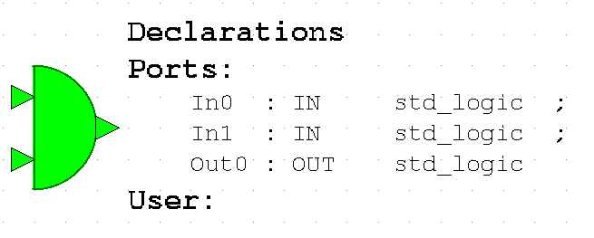
Figure V-7, HHandH symbol

HHandH is used to generate all bit products except for the last row, as the B inputs to the last row are inverted.

VHDL level simulation (Modelsim Simulation) results of HHandH are as shown in figure V-8. The signal traces display correct operation of HHandH.
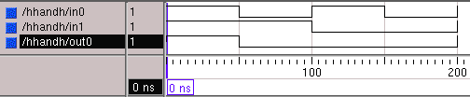
Figure V-8, HHandH simulation result

For each of the described components in the report, the Renoir symbols and schematic structural VHDL representations are in:
“CD>MSc/DesignFiles/Renoir/DesignData/componentname”. If component names are different from the subsection header, they will be written in parentheses in the title of subsection.

The generated VHDL codes are in:
“CD>MSc/DesignFiles/Renoir/HDL/componentname_vhdlarchitecturename”.

The compiled files for VHDL simulation with Modelsim are in:
“CD>MSc/DesignFiles/Renoir/CompiledData/componentname/”

The Modelsim simulation results are in:
“CD>MSc/DesignFiles/Renoir/ModelSimResults/componentname”

Included Renoir figures, either captured from Renoir graphical interface – in case of symbols – or printed as postscript files – in the case of structural design blocks – can also be referenced from:

“CD>MSc/DesignFiles/report/renoirfigs/componentnamesym.gif” for printed symbols
and
“CD>MSc/DesignFiles/report/renoirfigs/componentnamestruct.ps” for attached structural designs.

For the rest of the report, all the described components and higher level blocks have the above correspondence with the attached CD, therefore they will not be referred individually for the sake of brevity.

V.2.2 – HLandH:
As the last row of partial summations requires inverted B inputs, a separate semi-inverted AND gate is generated. HLandH represents that input in0 of the AND gate is active high while input in1 is active low and output is active high. The symbol for HLandH is as shown in figure V-9. The generated VHDL code is attached in Appendix A-2.
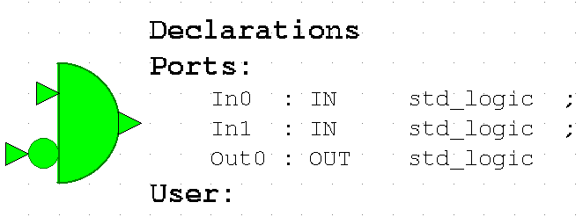
Figure V-9, HLandH symbol

VHDL level simulation results of HLandH are as shown in figure V-10. The signal traces display correct operation of HLandH.
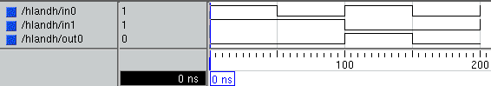
Figure V-10, HLandH simulation result

V.2.3 – Half Adder (HA):
The symbol for HA is as shown in figure V-11. The generated VHDL code is attached in Appendix A-3.
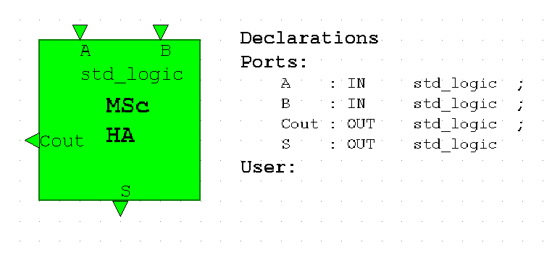
Figure V-11, HA symbol

VHDL level simulation results of HA are tabulated in table 9, which is acquired from the list window of Modelsim.

ns a b cout s
0 1 1 1 0
50 0 1 0 1
100 1 0 0 1
150 0 0 0 0
200 1 1 1 0
Table 9,HA Simulation List

As seen in the listed simulation results, HA functions in accordance with the specification.
V.2.4 – Full Adder (FA):
The symbol for FA is as shown in figure V-12. The generated VHDL code is attached in Appendix A-4.
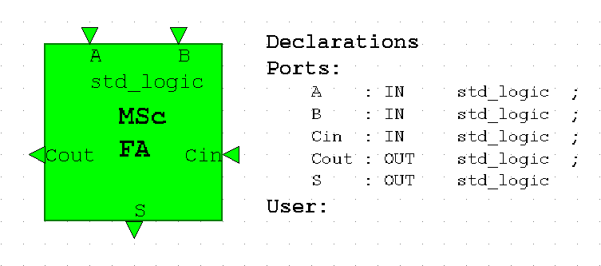
Figure V-12, FA symbol

VHDL level simulation results of FA are tabulated in table 10:
ns a b cin cout s
0 0 0 1 0 1
50 0 0 0 0 0
100 0 1 1 1 0
150 0 1 0 0 1
200 1 0 1 1 0
250 1 0 0 0 1
300 1 1 1 1 1
350 1 1 0 1 0
400 0 0 1 0 1
Table 10,FA Simulation List

As seen in the listed simulation results, FA functions as desired.

V.2.5 – Modified Full Adder for Signed Addition (MSBFA):
The symbol for MSBFA is as shown in figure V-13. The generated VHDL code is attached in Appendix A-5.
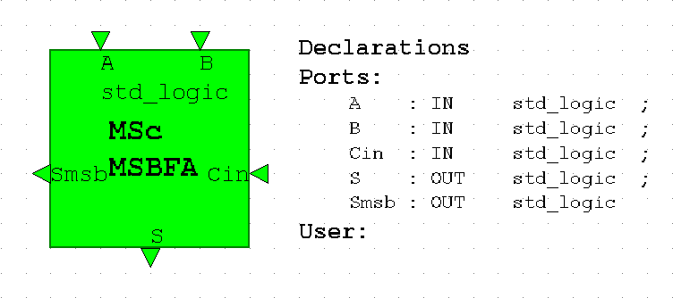
Figure V-13, MSBFA symbol

VHDL level simulation results of MSBFA are tabulated in table 11:
ns a b cin s smsb
0 0 0 0 0 0
50 0 0 1 1 0
100 0 1 0 1 1
150 0 1 1 0 0
200 1 0 0 1 1
250 1 0 1 0 0
300 1 1 0 0 1
350 1 1 1 1 1
400 0 0 0 0 0
Table 11,MSBFA Simulation List

As seen in the listed simulation results, MSBFA functions as expected.

V.2.6 – Signed Parallel 3x3 CPA Multiplier (CPAmult3x3):
With all the required leaf cells designed and assured for correct functionality, the 3x3 CPA multiplier is designed structurally in Renoir. The symbol associated with the 3x3 multiplier is as shown in figure V-14. The structural design, which is done in a semi-schematic manner in Renoir is attached in Appendix B-1 and the generated VHDL code is in Appendix A-6.

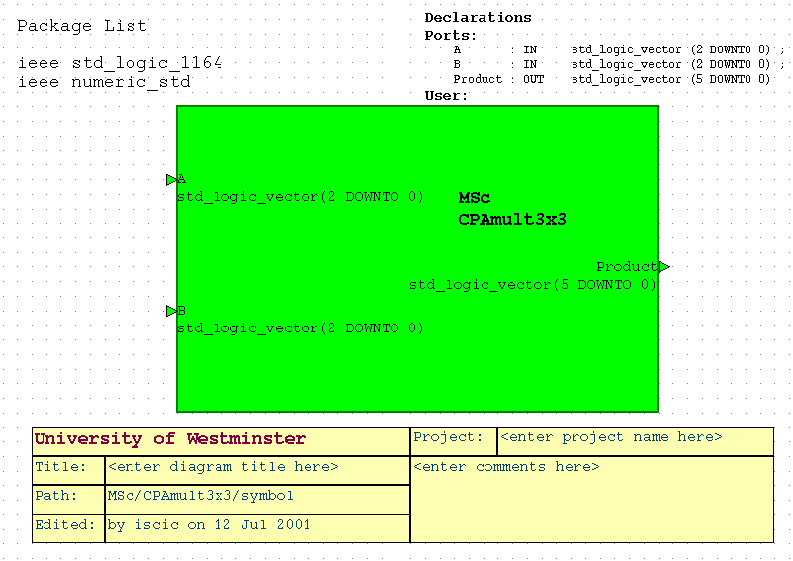
Figure V-14, CPAmult3x3 symbol

As seen in Appendix B-1, the designed multiplier is exactly the same structure described in figure V-6, with the bit product generation also included. VHDL level simulation results of CPAmult3x3 are tabulated in Appendix C-1, where the A, B inputs and P output are displayed in signed decimal format to provide easy examination of multiplier operation. As can be seen in the appendix, the correct functionality of 3x3 multiplier is verified in VHDL level simulation.

V.3 –Design of Parameterized CPA Multiplier
(CPAmultNxN)

Having ascertained the correct functionality of the signed parallel multiplier, we design the parameterized signed, parallel CPA multiplier. The generic structure of an NxN CPA multiplier, with a matrix shape rather than the demonstrated ladder like structure is shown in figure V-15.

Regarding the structure below, several for and if frames are used in Renoir in order to achieve the generic structure shown in Appendix B-2. For the bit products, an NxN matrix, ‘bpmatrix’ is defined, which holds the generated bit products by the matrix of AND gates. The generated matrix has the form:

$${\left[\begin{matrix}A_{n−1}{\bar{B}}_{n−1} & A_{n−1}{\bar{B}}_{n−2} & \text{.} & \text{.} & A_{n−1}{\bar{B}}_{0} \\ A_{n−2}B_{n−1} & \text{.} & \text{.} & \text{.} & \text{.} \\ \text{.} & \text{.} & \text{.} & \text{.} & \text{.} \\ \text{.} & \text{.} & \text{.} & \text{.} & A_{1}B_{0} \\ A_{0}B_{n−1} & A_{0}B_{n−2} & \text{.} & \text{.} & A_{0}B_{0}\end{matrix}\right]}_{\text{NxN}}$$
Row N-1
Row 1
Column N-1
Column 0
N-1 downto 1
N-1 downto 0

Hence, the described rows and columns refer to the rows and columns of generated matrix of HHandH and HLandH gates in the CPAmultNxN structural design.

A₀B_{N-1}
A₀B₁
A₀B₀
HA
A₁B₀
FA
MSB
FA
A₁B_{N-2}
A₁B_{N-1}
A_{N-1}
P_{2N-2}
P_{2N-1}
P_{2N-3}
P₁
P₀
A₀B_{N-1}
A₀B₂
FA
A₁B₁
HA
A₂B₀
FA
MSB
FA
A₂B_{N-2}
A₂B_{N-1}
FA
A₂B₁
P₂
FA
A_{N-1}(B₀)’
FA
MSB
FA
FA
A_{N-1}(B₁)’
A_{N-1}(B_{N-2})’
A_{N-1}(B_{N-1})’
P_{N}
P_{N-1}
(Row 2)
(Row 1)
(Row N-1)
(Col 0)
(Col 1)
(Col N-1)

Figure V-15, NxN CPA Multiplier Structure

As can be observed in figure V-15, the 1st and last rows are different from the intermediate rows, as 1st one has both inputs from bit products, and last one having FA in the LSB. Therefore, during generation, these two rows are isolated with 2 if frames in Renoir. The carries of the 1st row are propagated by ‘carryripple1’, an array of (N-1:0), with carripple1(i) corresponding the ripple between columns i and i-1. Therefore, carry in to the i^{th} column adder in the first row is carryripple1(i). The partial sums being transferred to the next rows are stored in a 2D array – not a matrix – named ‘sums’. The format of sums is

$$\left[\begin{matrix}\left[{\text{Partialsums}}_{{\text{from}}_{{\text{row}}_{1}}}\right] \\ \left[\text{.}\text{.}\text{.}\text{.}\text{.}\right] \\ \left[\text{.}\text{.}\text{.}\text{.}\text{.}\right] \\ \left[{\text{Partialsums}}_{{\text{from}}_{{\text{row}}_{N}}}−2\right]\end{matrix}\right]$$
Column N-1
Column 0
1to N-2
N-1 downto 0
Row 1
Row N-2

The partials sums are represented as an array of (N-1:0)elements representing the outputs of each partial sum row. i.e. sums(i)(j) represents the output from i^{th} partial sum row, and this partial sum’s j^{th} bit. The carries inside the intermediate generated rows are in a matrix of (2:N-2) rows, representing the rows of multiplier and (N-1:1) columns, representing the individual carries within a row. Similar to carryripple1, the ‘row’^{th} row and i^{th} column of this matrix, ‘carryripples’, represents the carry in to i^{th} column adder in row ‘row’. Finally, for the last row, the carries are stored in an array named ‘carryripple2’ functioning the same way as carryripple1 and the outputs are directly added to the MSBs of the product bus.

The corresponding symbol in Renoir, for the generated CPAmultNxN structural design is as shown in figure V-16 and the generated VHDL code from the structural design is in Appendix A-7.
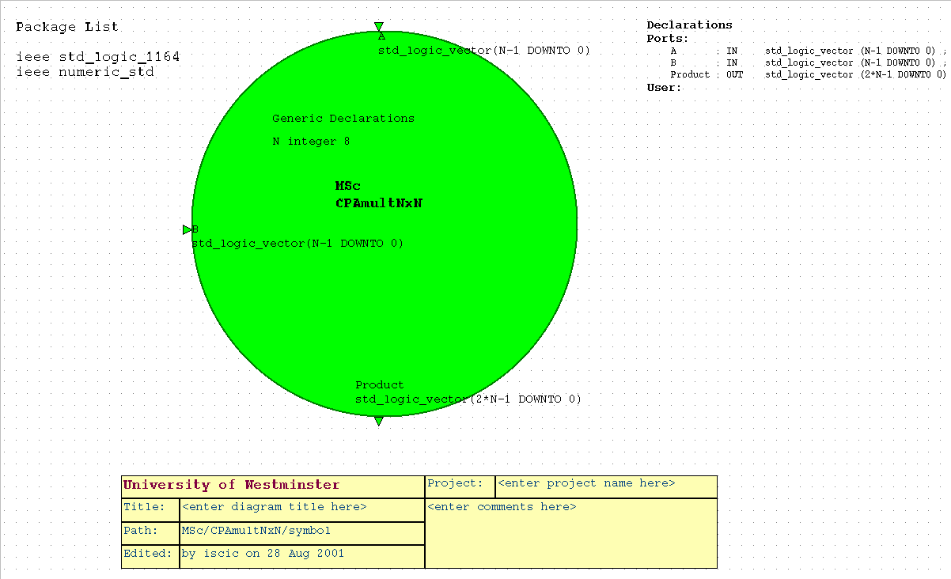
Figure V-16, CPAmultNxN symbol
The VHDL level simulation results for the parameterized CPA multiplier reveals correct operation of the design for various tried multiplier widths. An exemplary simulation result for an 8x8 multiplier (N=8) is as shown in figure V-17.

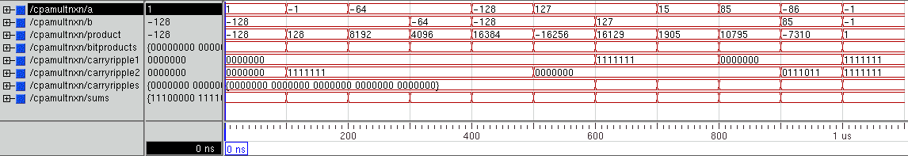
Figure V-17, Exemplary Simulation Trace for CPAmultNxN

After the completion of the design of the parameterized multiplier, the first step of the design entry has actually been finished and the next step in project progress is investigation of input pattern generation and output compression techniques. In terms of chronology, after the confirmed design of CPAmultNxN, we moved to reading the Renoir designs in QuickFault for fault simulation and the described design data management notions in section IV are scrutinized at this point. As described in section IV, the design pathway has been from Renoir → (QuickHDL) → Autologic → Design Architect → QuickFault and the operations done after these intermediate steps are the discussion of section VI. Therefore, chronologically, section VI is the next step performed after this point and it is recommended that the following subsections within this section are referred back after the examination of section VI.

V.4 –Design of Parameterized Signature Analyzer
(Signalyzer)

As described in section VI, the output compression technique chosen is signature analysis. Although the first signature analyzer is defined for 16 bits for an at most 255 vector input, here we introduce the design of a parameterized signature analyzer which can be configured for required number of bits and characteristic polynomials.
The associated symbol for the signature analyzer is as shown in figure V-18 and the VHDL code is attached in Appendix A-8.
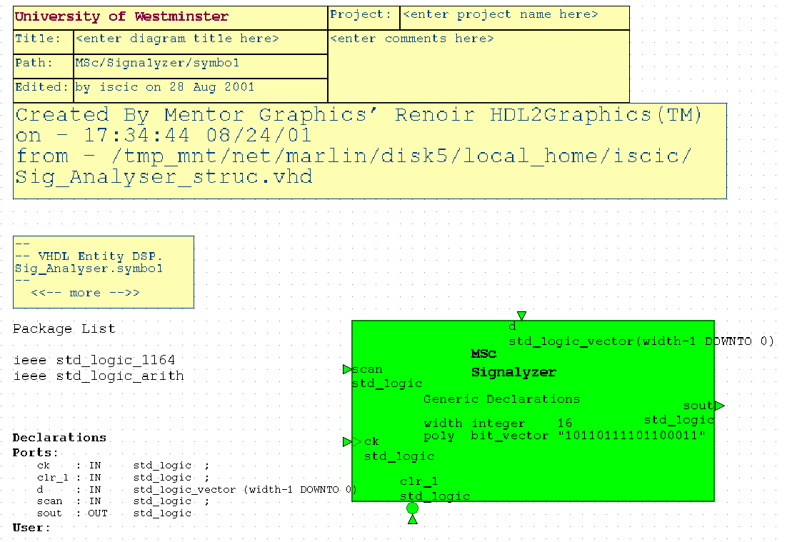
Figure V-18, Signalyzer symbol

The width generic defines the width of the desired signature analyzer and the poly represents the characteristic polynomial for the signature analyzer, which defines the tap locations.

An informative VHDL level simulation for the signature analyzer is shown in Appendix C-2, which uses the characteristic polynomial defined for the specific 8x8 multiplier. Therefore, the signature analyzer is run for 256 clock cycles and is seen to have a period of 255 as expected due to the polynomial used. The simulation is done so that, D inputs to signature analyzer are kept at all 0s to prevent any interference from input and to make the signature analyzer work like an LFSR, except for the first cycle where the LSB is kept 1 to initiate the feedback after clear. As seen in the simulation list, the signature analyzer works exactly as expected in VHDL level.

V.5 –Design of 8x8 Multiplier + Signature Analyzer
(MultSign8x8)

After the signature analyzer is assured for correct operation, multiplier and signature analyzer are connected in a higher hierarchy to initiate the design of final circuit with BIST circuitry also included. The Renoir symbol for the designed system is as shown in figure V-19. The Renoir structural design for the MultSign8x8 is attached in Appendix B-3 and the generated VHDL code for the multiplier + signature analyzer circuit is attached in Appendix A-9.

The generics ‘signpoly’ and ‘Nmult’ describe the characteristic polynomial of the signature analyzer and width of the NxN multiplier respectively. As seen in the structural design in Appendix B-3, the product bits are connected to signature analyzer ‘d’ input and the serial signature analyzer residue is clocked out via ‘sout’.

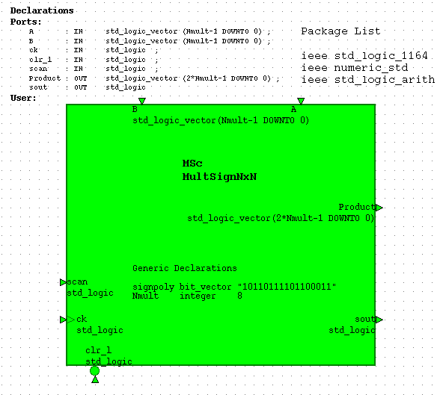
Figure V-19, MultSign8x8 symbol

A demonstrative VHDL level simulation of MultSign8x8 is as tabulated in table 12. As seen, scan input, which disables the parallel ‘d’ inputs to the MISR is always kept false, as this feature is not used in general in the way signature analysis is done during the project. As Modelsim permits different types of signal radix in the same list, in most Modelsim lists and traces, the ‘a’, ’b’ and ‘product’ buses are displayed in signed decimal format for quick analysis of signal values’ concordance with the expected multiplier behavior. Yet, on the other hand, most of the LFSR type output signals are displayed in hex format and ‘a’ and ‘b’ might be therefore displayed also in hex for PRBS input pattern generation analysis cases.

As can be deduced from the simulation list, the multiplier + signature analyzer circuit works in the expected way, where ‘sout’ will be the primary output observed by the tester during testing.

ns | Scan | clr_l | Ck | b | a | product | sout
0 | 0 | 0 | 1 | -1 | 1 | -1 | 0
50 | 0 | 1 | 0 | -1 | 1 | -1 | 0
100 | 0 | 1 | 1 | -1 | 1 | -1 | 1
150 | 0 | 1 | 0 | -1 | 0 | 0 | 1
200 | 0 | 1 | 1 | -1 | 0 | 0 | 0
250 | 0 | 1 | 0 | -1 | -128 | 128 | 0
300 | 0 | 1 | 1 | -1 | -128 | 128 | 0
350 | 0 | 1 | 0 | 127 | -128 | -16256 | 0
400 | 0 | 1 | 1 | 127 | -128 | -16256 | 0
450 | 0 | 1 | 0 | 127 | 127 | 16129 | 0
500 | 0 | 1 | 1 | 127 | 127 | 16129 | 0
550 | 0 | 1 | 0 | -128 | -128 | 16384 | 0
600 | 0 | 1 | 1 | -128 | -128 | 16384 | 0
650 | 0 | 1 | 0 | -86 | 85 | -7310 | 0
700 | 0 | 1 | 1 | -86 | 85 | -7310 | 1
750 | 0 | 1 | 0 | -86 | 85 | -7310 | 1
Table 12,MultSign8x8 Simulation List

V.6 –Design of Parameterized LFSR (LFSR)

In order to finalize the BIST circuitry, the LFSR is designed as the last hierarchical block in the design process. After investigation of several BIST input pattern generation techniques in section VI, the technique decided upon is PRBS generation using an LFSR with seed = x7B (0111 1011), where also repetitive patterns are used to have a constant volume of test vectors with an insignificant downgrade on fault detection efficiency. As described in section VI, a repetition length 4 sequence is used, meaning 2⁴ = 16 different inputs repeated for the length of each ‘a’ and ‘b’ multiplier inputs. In order to apply all possible combinations these two 16 repeated patterns, 16.16 = 256 vectors are needed, yet with the LFSR, 255 of these 256 patterns are provided, with all 0s, which is already observed to have zero effect after the 255 vectors, unprovided.

To provide a more flexible overall system in VHDL description, the designed LFSR is constructed as a parameterized LFSR with the tap locations, seed and length explicitly defined by the designer. The used LFSR structure, is the TDL type (Type A) LFSR, due to its better path delays as the XOR gates are separate from the flip-flop chain. The associated Renoir symbol for the generated LFSR is as shown in figure V-20 and the generated VHDL code is in Appendix A-10.

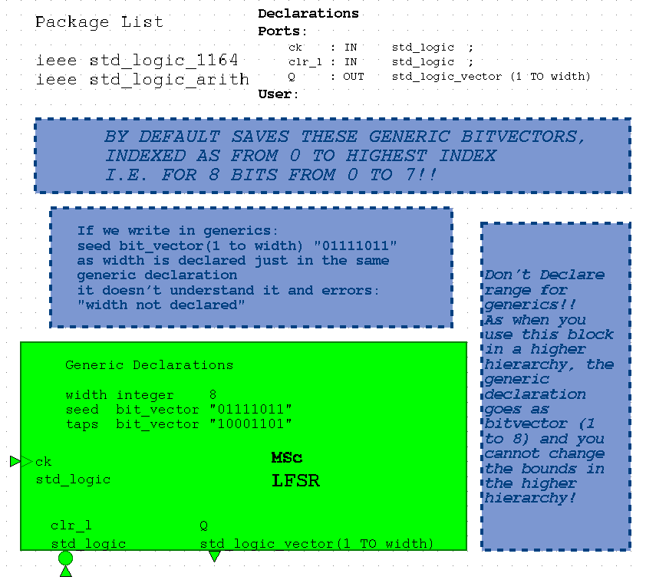
Figure V-20,LFSR symbol

The generic, width, defines the length of the LFSR, seed defines the initial seed to be used, which the LFSR is set to when clr_L is active and taps define the taps of the LFSR. For the seed, the leftmost bit represents the seed into the leftmost flip-flop, and the rightmost bit represents the seed into the rightmost cell. For the taps, a ‘1’ represents an existing tap while a ‘0’ represents a nonexistent tap, leftmost bit referring to the leftmost flip-flop and rightmost bit to rightmost flip-flop. As an example, the hardware to be realized for the generic values given in figure V-20, which is actually the LFSR used in the final BIST circuitry is shown in figure V-21. Seed = “01111011” describes the 1st and 6th flip-flops are reset, while the rest are set. Taps=”10001101” describes that there are taps from the outputs of 1st, 5th, 6th and 8th flip-flops, which also reveals the characteristic polynomial of the used 8 bit LFSR is:
1 + x¹ + x⁵ + x⁶ + x⁸

Figure V-21, Structure of LFSR
s_{in}
clr_L
_{Qint(8)}
F-F
8
Q(8)
seed(8)
_{Qint(7)}
F-F
7
Q(7)
seed(7)
_{Qint(6)}
F-F
6
Q(6)
seed(6)
_{Qint(5)}
F-F
5
Q(5)
seed(5)
_{Qint(4)}
F-F
4
Q(4)
seed(4)
_{Qint(3)}
F-F
3
Q(3)
seed(3)
_{Qint(2)}
F-F
2
Q(2)
seed(2)
_{Qint(1)}
F-F
1
Q(1)
seed(1)
CK

The VHDL level simulation, for the LFSR with the above parameters used is shown in Appendix C-3. The simulation list is strobed at every 90ns, therefore, only one Q output change is displayed per row. The initialization period is the first 50 ns and is not displayed in the simulation list. The input signals are produced as demonstrated in figure V-22:
clr_L
CK
50 ns
100 ns

Figure V-22, LFSR Simulation input Signals

As seen in the simulation list, the 8 bit LFSR with the given characteristic polynomial produces a maximum length sequence, with a period of 255. Seed B7 is the next state after the listed last state F6, strobed at 25490 ns.

V.7 –Design of Top Level System (LFSRMultSignNxN)

After the evident VHDL simulation results for the LFSR, all of the required blocks for the top level design are completed and assured of correct operation. In this section, we build the final system with BIST circuitry for both input pattern generation and output compression included. In the top level structural design, which is attached in Appendix B-4, it is seen that the 4 right bits of LFSR’s ‘Q’ output, Q(5:8) in figure V-21 are assigned to both 4 bit portions of multiplier’s ‘a’ input, a(7:4) and a(3:0); and 4 left bits of ‘Q’ output, Q(1:4) in figure V-21 are assigned to both 4 bit portions of multiplier’s ‘b’ input, b(7:4) and b(3:0). As discussed in section VI, this 4 bit long repeated pattern of input test patterns are seen to be very effective in fault detection, revealing a very high fault coverage with a small set of test vectors. Identical to MultSign8x8 design, the output of multiplier, product, is fed to the ‘d’ input of signature analyzer and the ‘sout’ output of signature analyzer reveals the codeword for compressed output data. Although the whole system is designed to be parameterized for variable sizes of multiplier, LFSR and signature analyzer, variable tap locations and seed for LFSR, and variable characteristic polynomial for the signature analyzer, the assignment of Q output bits to multiplier inputs is required to be done manually for each design as stated on the Renoir structural design sheet. This is to provide the designer with sufficient flexibility for the choice of repetition length – 4 in our case – and any desired permutation of outputs.

The generated Renoir symbol for LFSRMultSignNxN is as shown in figure V-23 and the generated VHDL code for the design is in Appendix A-11.

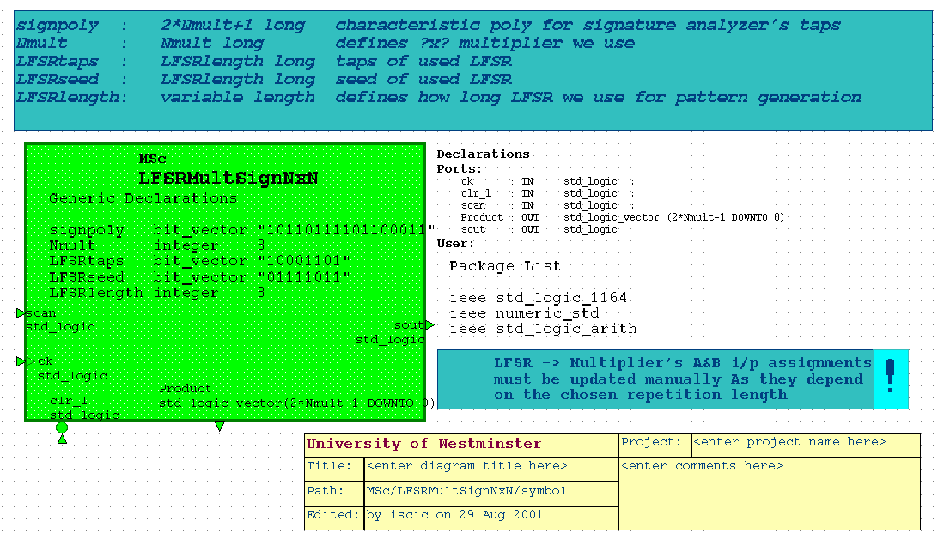
Figure V-23, LFSRMultSignNxN symbol

As seen in figure V-23, all the generic parameters from lower hierarchy is passed onto the top level and the top level design in general enables the specification of the multiplier as well as desired BIST circuit at the top level without the necessity to involve with the lower levels except for the case explained above and also exclaimed in the symbol.

The system inputs, clear and clock, have the same functionality as in the case of LFSR and scan input is the signature analyzer input which might be used to disable the multiplier output at the end of test run and the signature left in the signature analyzer can be clocked after the test input application, but in all our simulations we disable the scan input and strobe ‘sout’ during input test vector application.

The VHDL level simulation, with the generic parameters as assigned in the symbol figure, is attached in Appendix C-4. The simulation is again run for 255 clock cycles, which is the determined complete test for the system. The inputs clr_L and ck are driven as described in figure V-22 and scan input is always kept low as discussed formerly. As demonstrated in the simulation list, the signal values comply with the expectations. The LFSR is seen to take x7B seed value at the 266th cycle and traverses all the possible 255 states. The multiplier inputs and output are displayed in signed decimal and their functional operation is confirmed. The ‘sout’ values of signature analyzer are the primary test outputs that the test equipment observes during the 255 test cycles.

V.8 –16x16 Multiplier with BIST (LFSRMultSignNxN_16)

After the completed design of the top level system for the 8x8 multiplier, larger multipliers with BIST circuitry are designed in order to test the effectiveness of the applied constant set of test vectors. First a 16x16 multiplier with the BIST is designed. Due to the flexibility of the VHDL design, only the top level generics that are shown in figure V-23 are updated to the desired values and the internal LFSR output assignments are modified. As the symbol for the larger multiplier designs share the same symbol with LFSRMultSignNxN, the symbols are not printed again. The structural Renoir design which shows the LFSR output → multiplier input assignments for the LFSRMultSignNxN_16 is in Appendix B-5. As seen in the appendix, all the four 4 bit portions of both a and b inputs of the multiplier are assigned to Q(5:8) and Q(1:4) outputs of LFSR repetitively, thus, the inputs a and b having repeated patterns every 4 bits. The signature analyzer characteristic polynomial is computed from the high weight, Hamming distance 5 polynomial of the 16 bit signature analyzer by a simple polynomial multiplication, where the characteristic polynomial of 16th degree is multiplied by itself to produce a characteristic polynomial of 32nd degree. Hence, the length of the generated PRBS sequence is not increased as the newly computed polynomial is already a non-primitive polynomial with two factors of degree 16 – which are also computed from the polynomial multiplication of 2 different 8th degree polynomials -, therefore, the length of the PRBS that could be generated from the signature analyzer characteristic polynomial is the same length as of the 16 bit signature analyzer, which is chosen to have a length of 255. The polynomial multiplication in GF(2) (Galois Field of 2) for the32nd degree characteristic polynomial is as shown below:

(1+x²+ x³+ x⁵+ x⁶+ x⁷+ x⁸+ x¹⁰+ x¹¹+ x¹⁵+ x¹⁶) * (1+x²+ x³+ x⁵+ x⁶+ x⁷+ x⁸+ x¹⁰+ x¹¹+ x¹⁵+ x¹⁶) =

= 1+x⁴+ x⁶+ x¹⁰+ x¹²+ x¹⁴+ x¹⁶+ x²⁰+ x²²+ x³⁰+ x³²

Hence, this polynomial multiplication operation is best done via Matlab as polynomial multiplication is equivalent to convolution of coefficients. Therefore, the operation done in Matlab for characteristic polynomial calculation is:

Newpoly = mod(conv(oldpoly1,oldpoly2),2)

The mod₂ is to realize the arithmetic operation results in GF(2).

Acquired from the above calculation, the generic signpoly is assigned to:
“100010100010101010001010000000101”
and the generic Nmult is assigned to16. Other generics, which refer to the LFSR parameters are kept the same as figure V-23, as the input pattern generation scheme is constant, regardless of multiplier size. The VHDL code generated for the LFSRMultSignNxN_16, is attached in Appendix A-12 and the VHDL level simulation, is as shown in Appendix C-5. As seen in the simulation list, the inputs are driven the same way as in section V.7 and the results are in concordance with expectations.

V.9 –32x32 Multiplier with BIST (LFSRMultSignNxN_32)

After the fault simulation of LFSRMultSing16x16, a 32x32 multiplier is generated from the parameterized top level design. The signpoly generic is updated for a 64 bit signature analyzer, and the characteristic polynomial is acquired from polynomial multiplication of the characteristic polynomial for the 32 bit signature analyzer by itself. Evidently, the PRBS length from this polynomial will be still 255, which is the preferred characteristic for the max 255 pattern input test vectors. The polynomial multiplication is performed as described in section V.8 and the resultant signpoly generic value is:
"10000000100010000000100010001000100000001000100000000000000010001"

The Nmult generic is obviously assigned to 32 and the LFSR related parameters are not changed. The structural Renoir description of the LFSRMultSignNxN_32 is as shown in Appendix B-6. As the repetitive pattern scheme suggests, all the eight 4 bit portions of b inputs are assigned to Q(1:4) and all the eight 4 bit portions of a inputs are assigned to Q(5:8). The VHDL code generated from the structural description is attached in Appendix A-13 and VHDL level simulation of LFSRMultSignNxN_32 is in Appendix C-6, which reveals correct functionality.

V.10 –24x24 Multiplier with BIST (LFSRMultSignNxN_24)

As the fault simulation of the 32x32 multiplier failed due to insufficient memory space, a moderately smaller sized 24x24 multiplier is designed after 32x32 multiplier. The characteristic polynomial for the 48 bit signature analyzer is acquired by polynomial multiplication of the characteristic polynomials for the 16 bit signature analyzer and 32 bit signature analyzer, in the way described formerly. The resultant signpoly generic value is:
"1011111000110000101010011010100000110111011101111"
and the Nmult value is 24. The structural Renoir design of LFSRMultSignNxN is in Appendix B-7 and the generated VHDL code is in Appendix A-14. The VHDL level simulation reveals correct operation, but is not included in the appendix for brevity.

V.11 – Design Summary

Finally, having described all design blocks, the MSc design library in Renoir is displayed in figure V-24, to describe the overall design blocks and also each design and its appendix reference is shown for quick reference.
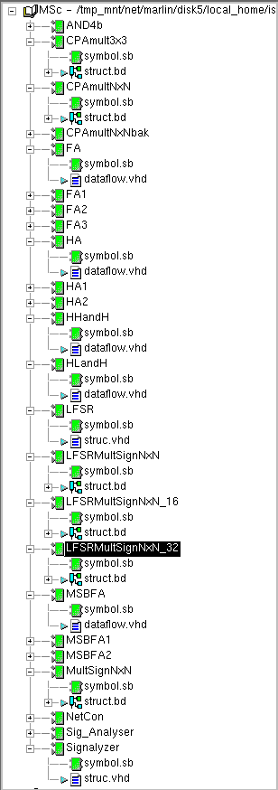
Appendix A-6 & Appendix B-1
Appendix A-7 & Appendix B-2
Appendix A-4
Appendix A-3
Appendix A-1
Appendix A-2
Appendix A-5
Appendix A-8
Appendix A-10
Appendix A-11 & Appendix B-4
Appendix A-12 & Appendix B-5
Appendix A-13 & Appendix B-6
Appendix A-9 & Appendix B-3
Figure V-24, Design Library

RTL level VHDL is used in almost all design codes in order to have direct control on synthesis process
As this design is done after the CD is written, the corresponding data is missing in the submitted CD

