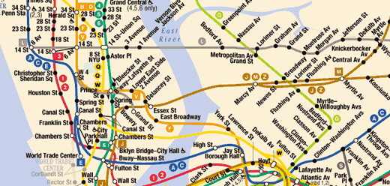
11:13 Dingil AL →
11:23 NJT to NY Penn Stn
12:38 NY Penn Stn.
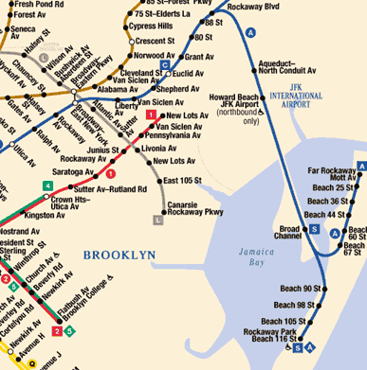
~ 13:00 – 13:15 Get Metrocard for $14
take MTA “A” <Far rockaway || Rockaway Park>
lasts ~ 1 hr15 (2$)
exit at HOWARD BEACH/JFK AIRPORT STN

~14:30 take airtrain to terminal 1
around 12 mins
~14:45 Exit at terminal 1(THY) / 6(JetBlue)

KENNEDY AIRPORT (JFK)
A train
Take the A to the JFK airtrain and get to JFK Airport in about 70 minutes from lower Manhattan. A service to the airport operates every 10 to 15 minutes during rush hours and every 20 minutes at other times. AirTrain stops at Howard Beach every 4 to 10 minutes.
Be sure to take the A that is marked Far Rockaway or Rockaway Park, not Lefferts Blvd. Get off at the Howard Beach/JFK Airport station. If you are carrying more than one suitcase, or if what you are carrying is heavy, be aware that you will need to walk the length of the station platform, climb one stairway and descend another.

