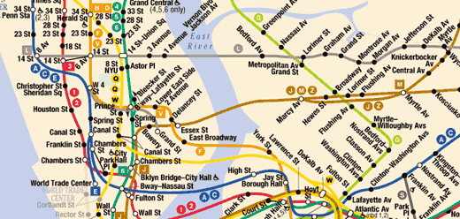
10:58 Dingil AL → kacirma sicarsin
11:13 NJT to NY Penn Stn
12:21 NY Penn Stn.
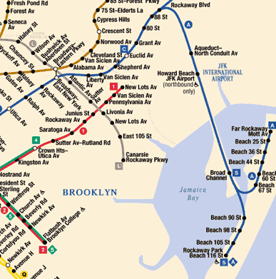
~ 12:45 – 13:00 take MTA “A” <Far rockaway || Rockaway Park>
lasts ~ 1 hr (1.5$)
exit at HOWARD BEACH/JFK AIRPORT STN

~14:00 take free shuttle route to terminal 1
around 20 mins
~14:30 Exit at terminal 1

KENNEDY AIRPORT (JFK)
A train
Take the A to the free airport shuttle bus and get to JFK Airport in about 70 minutes from lower Manhattan. A service to the airport operates every 10 to 15 minutes during rush hours and every 20 minutes at other times.
Be sure to take the A that is marked Far Rockaway or Rockaway Park, not Lefferts Blvd. Get off at the Howard Beach/JFK Airport station. If you are carrying more than one suitcase, or if what you are carrying is heavy, be aware that you will need to walk the length of the station platform, climb one stairway and descend another to reach the airline shuttle bus stop. A luggage cart makes the going easier.
At the station you will see a large map that lists every airline and its terminal name and number. There are two free shuttle bus routes, "A" and "B", which operate 24 hours a day. If you are not sure which shuttle bus to use, ask the bus operator.

